Live the Big Adventure



2026 Camp Leaders Guide

Bradley Scout Reservation 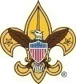 Mountain West Council

Nationally Accredited Camps and Staff

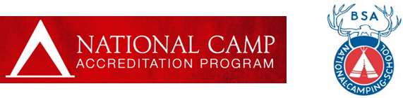

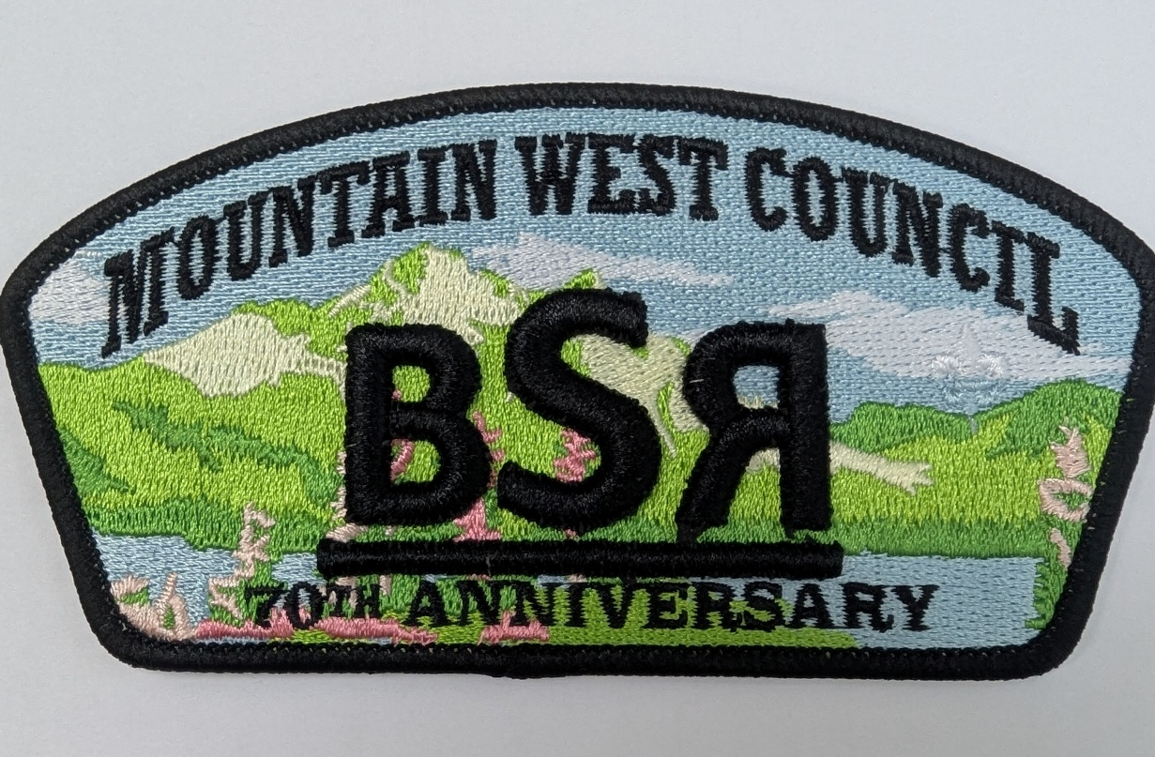

This Leader Guide contains general camp information regarding...
- fees
- policies and rules
- camp programs
- food service
- health and safety rules
- travel information
- and much more

To assist unit leaders to better prepare to attend Bradley Scout Reservation. Supplemental forms specific to camp are also included for your convenience in the Appendix. If there is information you need not contained in this guide, please contact the MOUNTAIN WEST COUNCIL Office at (208) 376-4411.

Mountain West Council Promise to You

Dear Camp Troop Leader,

This Camp Leaders Guide is a positive demonstration of how we have combined operations and management of two different council camps. This effective operation maintains outstanding service to your Troops in a cost-efficient matter to meet the changes we are experiencing. While the number of weeks is reduced, we are working hard to continue great programs and adventures to provide your Troops with a wonderful Scout camping experience, positive advancement opportunities, and a fantastic FUN time!
Bradley Scout Reservation will have a great staff, chosen from the top scouters in the nation, that are trained to the same high quality as in past years. This Leaders Guide contains the detailed information you need to prepare for a Scout camp experience that challenges your Troops.

The council has made great efforts in selecting staff leadership to ensure superior experience for your Troop. Our camp has been featured in Boy’s Life and Scouting Magazine as one of the best in the BSA.

R.D. Hill will be returning for his 6th year to be your 2026 camp director for Bradley Scout Reservation. He has a long history in Scouting and is currently serving as the Crew Advisor to Crew 1825 and as an Assistant Council Commissioner.

We look forward to seeing you at camp and hope you will be able to take an opportunity after camp to provide feedback on how we can improve our service to you. Please call if you have any questions or concerns about the 2026 summer camp programs.

Welcome to Bradley Scout Reservation

Dear Camp Troop Leader,

Are you ready for an unforgettable adventure? A great experience at Scout camp doesn’t happen automatically, it requires planning. Using resources provided by Scouting America and by the Bradley Scout Reservation, your patrol leaders’ council (supported by your Scoutmasters and troop committee) can prepare beforehand to meet the needs of youth within your troop to have a great experience at Scout camp!

It is also the purpose of Scouting America to provide for youth an effective program designed to build desirable qualities of character, to train them in the responsibilities of participating citizenship, and to develop in them personal fitness, thus, to help in the development of American citizens who have a high degree of self-reliance as evidenced in such qualities as initiative, courage, and resourcefulness.
The Bradley Scout Reservation offers several excellent program resources to troops, all of which are outlined in this Leaders Guide as well as the accompanying program guide.

There is increased interest in providing Scouts with usable Scouting and life skills. To achieve this goal, we have made some adjustments to the traditional schedule. Please be aware that these changes were made with the intent to better serve the youth and Scouting ideals.

You will also note that some changes were made to remain in compliance with current health and safety standards.

We hope you have a great time at Bradley Scout Reservation this coming year helping the youth of your unit make lasting memories and have a very positive camping experience. We look forward to meeting you!

R.D. Hill
Camp Director, Bradley Scout Reservation
Mountain West Council

Health and Safety Is a Special Emphasis Items

BSA Annual Health and Medical Record - Physical (Only Use the Current Official BSA Form)

Everyone attending camp for any period must have a Physical completed within the past 12 months as of arrival and, as specified below, no exceptions. Parts A, B, and C are required for all Scouts and adults who will remain at camp a combination of 72 hours or longer.
- Campers arriving without a physical on the correct form signed by certified and licensed physicians (MD, DO, Nurse Practitioners, or Physician Assistants) must obtain a physical within 72 hours to remain at camp.
- Part A and B are required for anyone who will be at camp 72 hours or less.
- Campers who will be at camp 72 hours or less are not required to see a physician, just complete Parts A and B.
- The correct form is LOCATED at the following website: https://bit.ly/3Sh8WRV
- School physicals, other types of physicals, and physicals on the incorrect or outdated forms will not be accepted.
- Physicals signed by Chiropractors, RNs, LPN's, etc. or any other healthcare provider not listed above will not be accepted.

.

Safeguarding Youth Standards at Camp
Scouts BSA has a successful policy concerning the protection of youth and adults at camp. This policy is contained in the two-deep policy that every unit must abide by. We train all camp staff members in these policies to ensure a safe and secure environment at Camp. Please ensure all leaders from your troop follow these policies.

ALL ADULT LEADERS WHO WILL SPEND THE NIGHT AT CAMP NOW REQUIRE SAFETGUARDING YOUTH TRAINING

EVERY UNIT MUST HAVE AT LEAST TWO REGISTERED ADULT LEADERS PRESENT DURING THEIR ENTIRE STAY AT CAMP, TWO OF WHICH MUST BE 21 YEARS OF AGE OR OLDER. YOU CANNOT SWITCH OUT LEADERS UNTIL THE REPLACEMENT HAS ACTUALLY ARRIVED.

- Arriving leaders must check in at the Trading Post.
- Transportation to and from camp must be in safe and insured vehicles with seat belts for all passengers. Do not allow riders in the back of pickup trucks.
- Scouts are not to be in tents alone with adults at any time. This includes Parents under the new YPT.
- Scouts and adults must not shower or undress together at any time.
- There will be no one-on-one activities between Scouts and adults at any time.
- Do not use corporal punishment, hazing, and initiation, physical, sexual, or emotional punishment at any time.
Two registered adult leaders must be in camp at all times. In emergencies, the unit leader may contact the Camp Director to request the camp to provide a second leader for a limited amount of time. See camp provisional leader fees. If going somewhere overnight, you still need two adults in camp.

Scouts and their parents expect all Boy Scouts of America activities to be conducted safely. To ensure the safety of participants, the Boy Scouts of America expects leaders to use the four points of SAFE when delivering the Scouting program.

SuperviSion

Youth are supervised by qualified and trustworthy adults who set the example for safety.
- Accepting responsibility for the well-being and safety of youth under their care.
- Ensuring that adults are adequately trained, experienced, and skilled to lead the activity, including the ability to prevent and respond to likely problems and potential emergencies.
- Knowing and delivering the program of the Boy Scouts of America with integrity.
- Using qualified instructors, guides, or safety personnel as needed to provide additional guidance.
- Maintaining engagement with participants during activities to ensure compliance with established rules and procedures.

ASSeSSment

Activities are assessed for risks during planning. Leaders have reviewed applicable program guidance or standards and have verified the activity is not prohibited. Risk avoidance or mitigation is incorporated into the activity.

Predetermining what guidance and standards are typically applied to the activity, including those specific to the Boy Scouts of America program.
- Planning for safe travel to and from the activity site.
- Validating the activity is age-appropriate for the Boy Scouts of America program level.
- Determining whether the unit has sufficient training, resources, and experience to meet the identified standards and, if not,
modifying the activity accordingly.
- Developing contingency plans for changes in weather and environment and arranging for communication with participants, parents, and emergency services.

FitneSS And Skill

Participants’ Annual Health and Medical Records are reviewed, and leaders have confirmed that prerequisite fitness and skill levels exist for participants to take part safely.

Confirming the activity is right for the age, maturity, and physical abilities of participants.
- Considering as risk factors temporary or chronic health conditions of participants.
- Validating minimum skill requirements identified during planning and ensuring participants stay within the limits of their abilities.
- Providing training to participants with limited skills and assessing their skills before they attempt more advanced skills.

equipment And environment

Safe and appropriately sized equipment, courses, camps, campsites, trails, or playing fields are used properly. Leaders periodically check gear use and the environment for changing conditions that could affect safety.

Confirming participants’ clothing is appropriate for expected temperatures, sun exposure, weather events, and terrain.
- Providing equipment that is appropriately sized for participants, is in good repair, and is used properly.
- Ensuring personal and group safety equipment is available, properly fitted, and used consistently and in accordance with training.
- Reviewing the activity area for suitability during planning and immediately before use, and monitoring the area during the activity
through supervision.
- Adjusting the activity for changing conditions or ending it if safety cannot be maintained.


Important Health and Safety Issues

Health Lodge

Our Camp’s medical officer maintains a first aid lodge, or infirmary for camper health and safety. Minor first aid incidents can be addressed by visiting the first aid lodge at camp. Serious injuries or incidents will require transport to the Medical Center in Stanley or Ketchum by the Camp Director or other senior camp staff, and a leader from the Troop adult.


Mosquitos at Camp
We do spray at camp for mosquitos, however because we are at a high elevation and close to water, we still battle new hatchlings. Use of bug spray is encouraged. Bug spray is available for purchase at the Trading Post. Mosquito coils or smoke deterrent items should be used with the same precautions as fires. Do not use these inside your tents. Off camp outposts, have many mosquitos!
When necessary, put on your mosquito repellent and ensure your Scouts put on theirs and follow the directions from the State of Idaho below:
“West Nile virus (WNV) is transmitted to people, birds and other animals by the bite of an infected mosquito. This virus can cause serious illness in people of any age, but especially in people over the age of 50 or those with other underlying medical conditions. You can protect yourself by avoiding mosquito bites. Taking the following precautions can help you "Fight the Bite."
Wear repellent containing DEET, Picaridin or Oil of Lemon Eucalyptus (all EPA-approved repellents) according to the label.
Cover up your skin with clothing between dusk and dawn, when mosquitoes are most active.”

A “Happy” Scout is a Hydrated Scout!
Please prepare Scouts to counter common health issues, especially dehydration and heat exhaustion. Symptoms of dehydration and heat exhaustion are more varied than just being thirsty or hot and may include nausea, loss of appetite, headache, dizziness, and muscle cramps. Please review the new Scout Handbook for symptoms and first aid of dehydration and heat exhaustion. Every camper should carry a water bottle with them and drink plenty of water while at camp.

Allergies
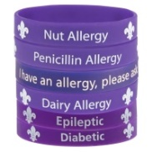
All Troop Leaders at Camp must be aware of and prepared to manage all allergies, health issues, or physical limitations of each Scout in their Troop. Leaders should ensure that their Scouts in their troop follow restrictions that are set by their doctors and parents.

Garbage

Each Troop is responsible for disposing of their garbage and keeping their campsite tidy. Every night your tied bagged trash from your campsite must be placed in the camp dumpster by 9:00 PM. It is very important to remove all items that may attract bears and other wildlife from campsites every day to provide camper safety. If you create trash (including food wrappers) after regular hours, you must bag it and carry it to the bear proof Dumpster. Doing this will ensure you get full points on camp site inspections!

Liquid Fuels Storage
Liquid fuels may only be kept in campsites if loaded into the storage reservoirs of camp appliances. Extra liquid fuels should be labeled with the troop number and campsite and checked in the flammable storage shed. See Camp Commissioner.

Incident reporting
Any adverse incident or injury to a Scout, or Scouter at camp MUST be reported to the Camp Director.
Please use the following Incident Reporting Tool for this purpose. A Safe camp is a Good camp.

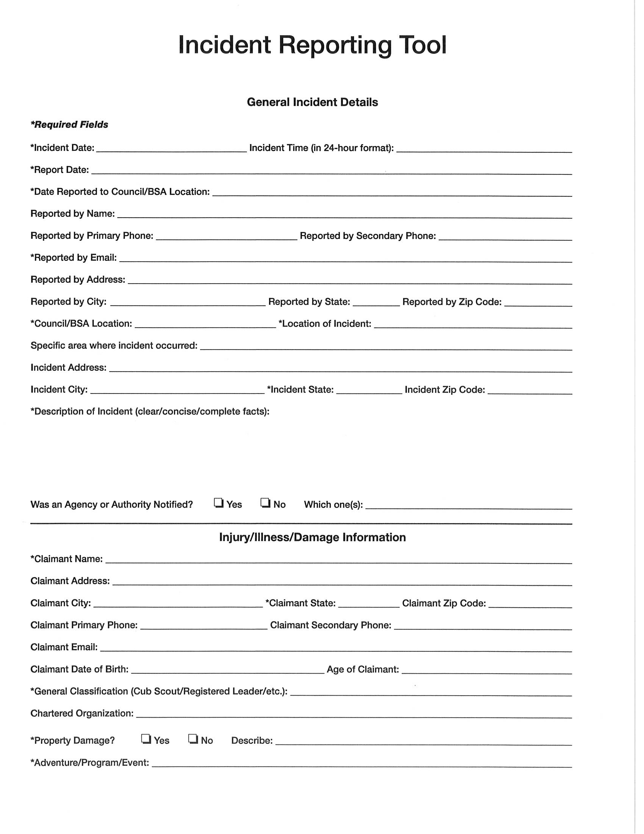
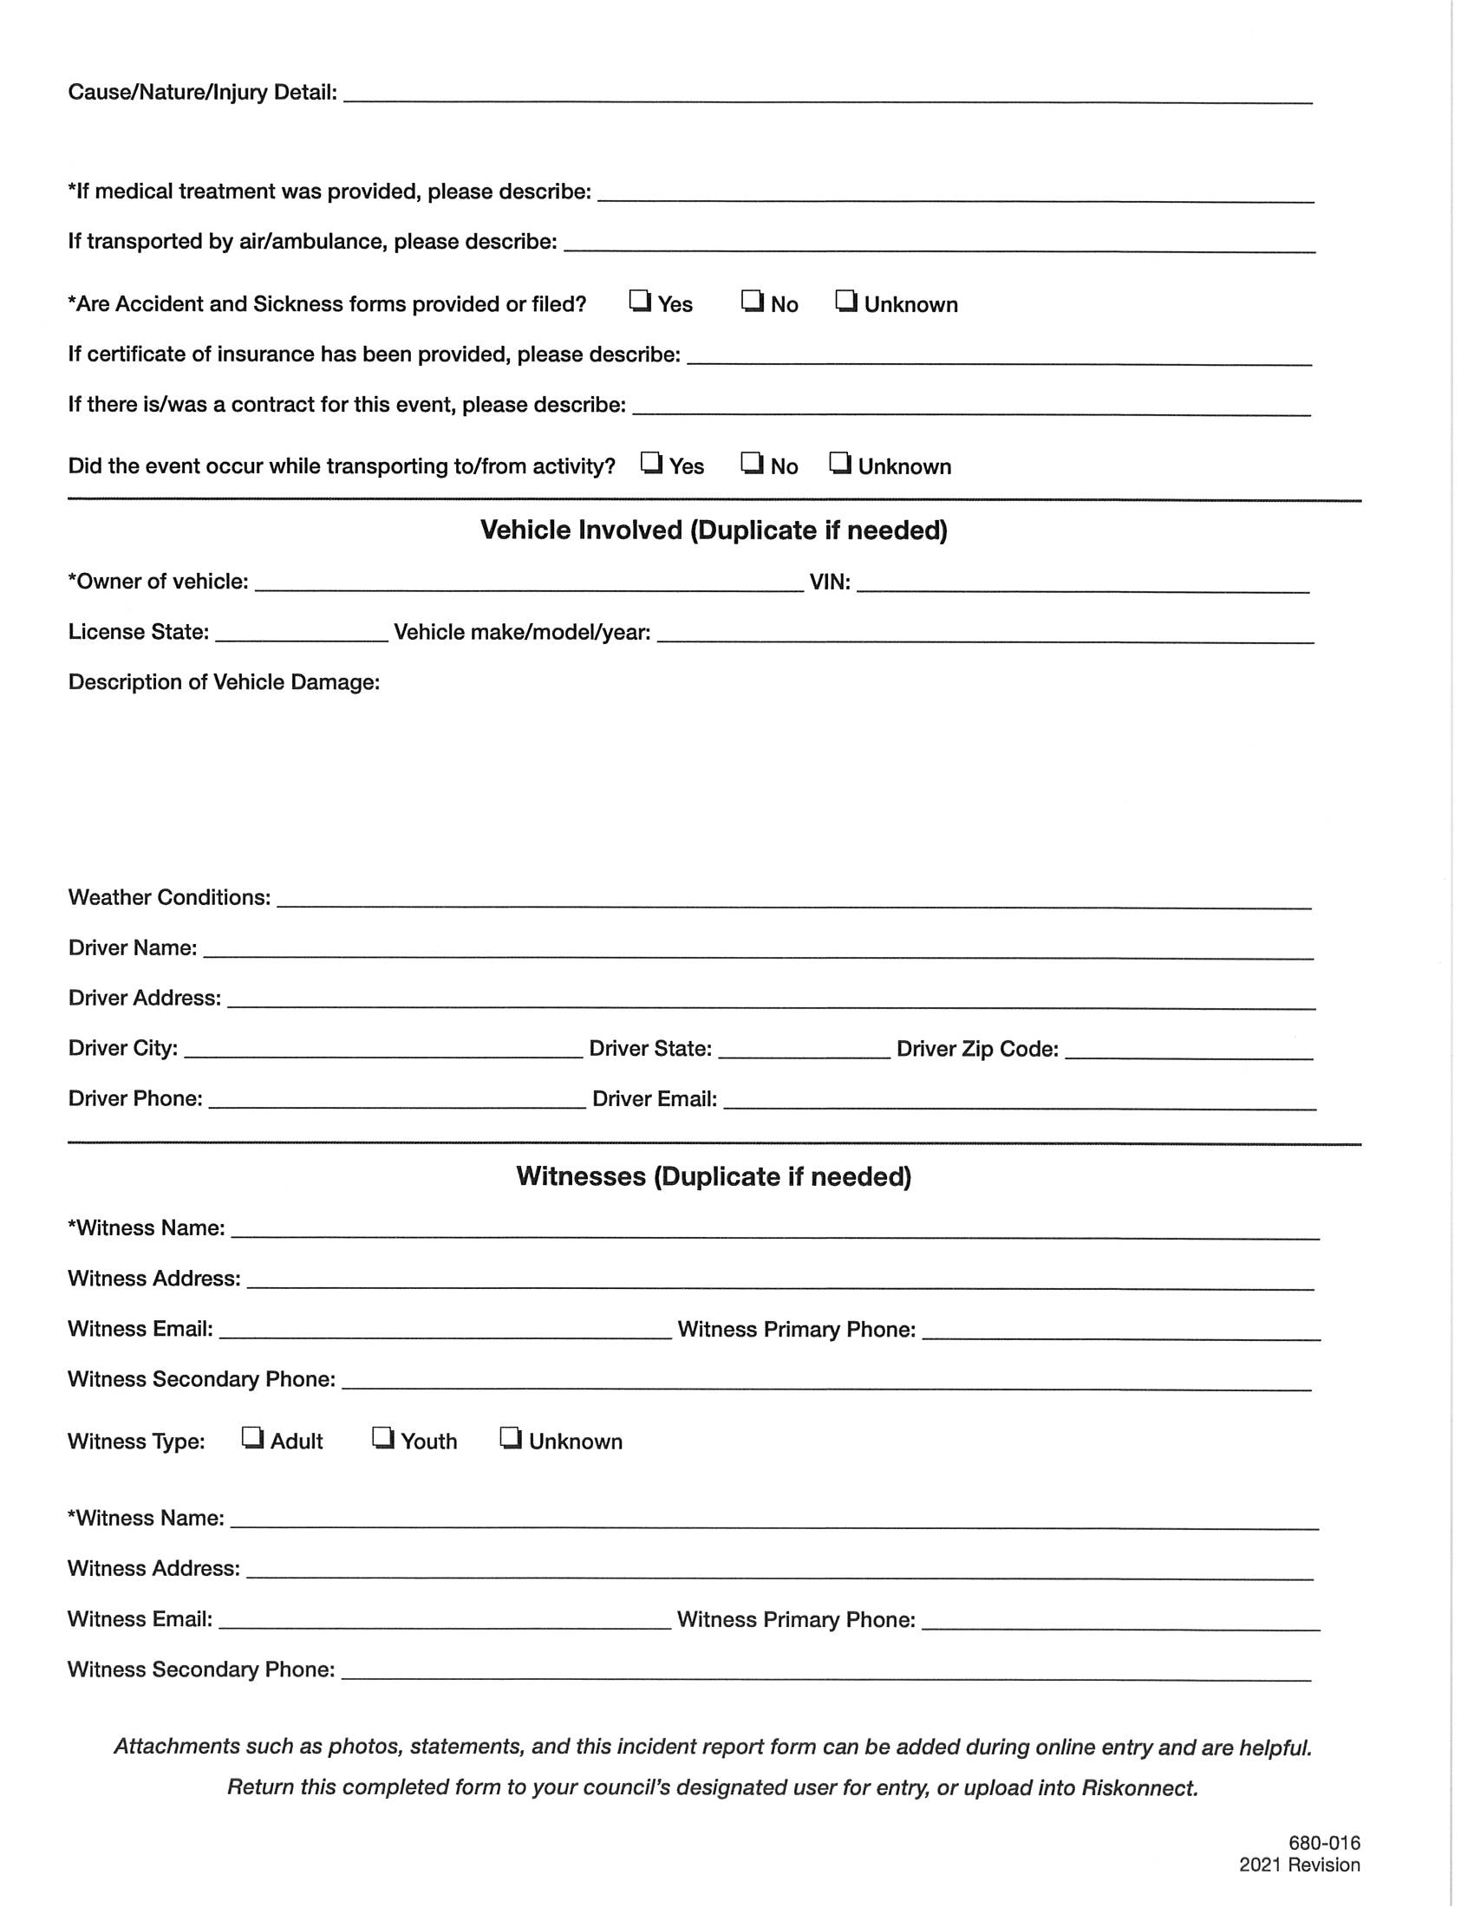

Safety Around Animals


Our camps cover a large area and offer a wide range of exciting adventures including the opportunity to observe many types of birds, fish, and wildlife. Throughout camp, you will see numerous animals especially squirrels, chipmunks, and common birds. Undoubtedly, the opportunity to observe a raccoon, turkey, deer, eagle, or even a black bear will provide lifetime memories.
Animals often will be an exciting part of your adventures. Seeing them in their natural habitat is always a pleasure, but it is wise to remember that they are the permanent residents of the backcountry or camp while you are a visitor. Treat them with respect, give them enough space so they will not feel threatened by your presence, and they will seldom present a threat to your safety. When an animal feels frightened, threatened, or trapped, it may fight for its life by attacking, scratching, and biting. In the event you are injured, seek treatment quickly; a doctor must determine whether rabies treatments will be necessary.
Each of the animals who live and roam throughout our camps have their own characteristics and patterns of behavior.
Young wildlife sometimes strays from their parents and appear to be lost or abandoned. In most cases, however, the parents know where the youngster is. Taking in apparently lost or abandoned young usually does more harm than good. Wild animals are best left in the wild. If the animal is obviously sick or injured, notify the Camp Director or Camp Ranger.

General Wildlife Safety and Habitat Stewardship
Hike only on designated trails
Keep a clean campsite
Keep food and smellables out of your tent
At night hang food and smellables in bear bag at least 12 feet above ground
Never approach or follow wild animals
Do not attempt to take pictures of dangerous or frightened wild animals
Do not feed wild animals
Don’t mistake a passive animal as a sign of safety
Never tease or attempt to pick up wildlife (they bite . . . hard)
Avoid aggressive behavior:

- Direct eye contact, even though a camera
- Walking directly towards an animal
- Following an animal that has chosen to leave
- Circling or standing around an animal
- Leave young animals alone; a protective mother is usually nearby
- Stay away from dead animals and berry patches, important food sources for bears

Encounters with Bears
Unit leaders should review this section with members of the troop before attending camp. Bears are not “cute” and Scouts should never seek contact with a bear. In a bear encounter remember that your actions can affect the outcome.
Black bears are regular visitors to the camp (especially during drought and when there are nearby forest fires). Despite the common name, black bear, they are not always black. They may be honey-colored, blond, brown or black. They may have a tan muzzle or a white spot on their chest.
Avoidance of bears and most wildlife can be summed up in one word—FOOD. If an animal does not find abundant food, it will move on.
Most conflicts between people and wildlife, especially bears are linked to careless handling of food or garbage. Learn to live responsibly with wildlife.
- Maintain a safe distance and behave in a manner that does not threaten the bear.
- Back out of the situation, if possible.
- Stay calm, stay together, avoid eye contact, back away slowly, and speak in a soft tone.
- Do not run from a bear.
- Bears that feel threatened may at first make a bluff charge to scare or knock down someone they perceive as a threat.
- Stand your ground in a bluff charge, but do not threaten the bear.
Bears are more likely to feel threatened if they are surprised and unable to avoid a confrontation.

Report all encounters or sightings to the Camp Director or Camp Ranger immediately.

Bradley Scout Reservation Highlights

In addition to Scout rank advancement activities, there are more than 20 merit badges offered including: astronomy, basketry, environmental science, fish and wildlife, first aid, soil and water conservation, wilderness survival, and woodcarving.

The waterfront offers opportunities for, kayaking at Bradley Scout Reservation, canoeing, rowing and swimming.

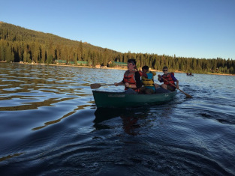

A first class, shotgun and small caliber shooting range is available for use of all campers. Shooting skills are learned on a safe and well-supervised range allowing campers to shoot clay targets and practice their shooting skills. The archery range is available for obtaining the archery merit badge and recreational archery shooting for all campers.

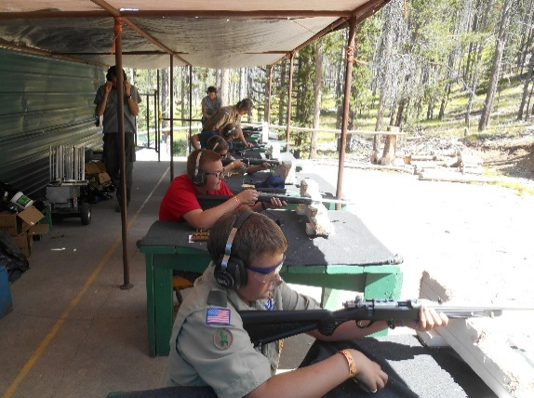
Scouts can earn merit badges while they are at camp, but if that is the only reason they are coming to camp, the key element is missing. Bradley Scout Reservation will be your greatest opportunity as a leader to show your Scouts that you are a caring adult who can help them through life's challenges.

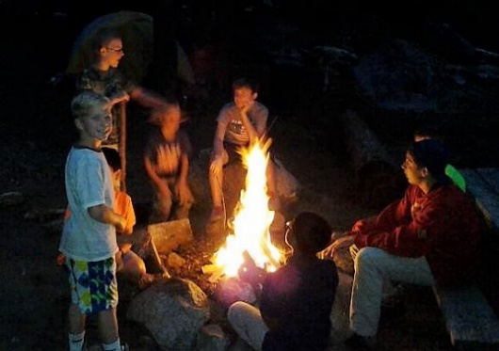

The most important things that happen at camp happen in the campsite after the daily program is done. Reserve your campsite and plan your activities now! Please schedule time for personal achievement (merit badges or rank advancement), unit service projects, and fun.

This Leader's Guide will give you all the information you need to have a great week at camp. There are over 20 outdoor-related merit badges in staffed program areas. The Bradley Scout Reservation and Adventure programs include fishing and climbing programs for older Scouts and adults. Shooting sports, ecology and conservation, Scoutcraft activities, and handicrafts provide opportunities for Scouts of all ages. A campfire program that can rival professional theatre will crown your summer camp experience. A Scout's dream of a real wilderness survival experience is waiting to be fulfilled at Camp.

Bradley Scout Reservation Service Corps.

This year, the BSR will be celebrating two milestones. The first is the reopening of the BSR for the use, enjoyment and edification of scouts from all over the world.

The second is the 70th anniversary of the Bradley Scout Reservation as a destination camping experience for all youth.

Since 1956 this location has been providing lifelong adventures and memories for untold numbers of scouts.

This year we are issuing the inaugural movement of the Service Corps. By selecting a campsite and “claiming it as your own” you will be able to select the name of the campsite, from the list of approved names, and you will be supported in the campsite rejuvenation and establishment of new camping traditions and set up of “your campsite” for generations of scouts to come.

Staff support will be provided by a specific Service Corps Commissioner in the form of Kip Higby.

Kip has been a long-time scouter in the Mountain West Council and is a former Scoutmaster of Troop 1 and a prior unit commissioner. Kip will be available to guide your scouts in the leadership and format to make the New BSR a place that your troop is eager to return to and continue the service to the area and camp that we all love.

Grab a shovel, a map, a sign, and some soul and build a camp that your troop can be proud to return to year after year for more memories and drive of life.

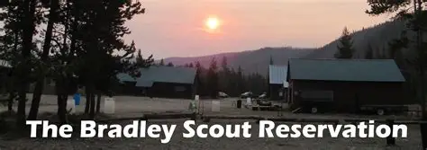

About Bradley Scout Reservation

Bradley Scout Reservation is the ideal location for Boy Scouts to have the ultimate camping adventure. It was originally named the Cape Horn Scout Reservation; Camp Bradley, was purchased by the Snake River Council in 1956. Celebrating its 70th year, Bradley Scout Reservation has had both good and bad experiences. From team building experiences and leadership training to fires that nearly took the whole camp, it’s been the summer camp location for generations of Scouts. In its first year, 1938 Scouts attended and started the legacy of great camping at Bradley Scout Reservation.
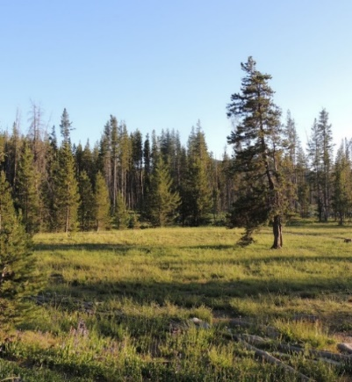
In July 1957, Archie Brown and Arrowmen from the Ma-I-Shu Lodge of the Order of the Arrow, pioneered 58 miles of rough wilderness to form the Ma-I-Shu Trail. Portions of this trail are available for a Troop to hike during their stay at Bradley Scout Reservation.
During the summer of 1962, the remaining $15,000 mortgage on the Cape Horn Scout Reservation was paid in full by Mr. and Mrs. J. G. Bradley and Mr. and Mrs. James H. Shields, Jr. The gift was made in memory of Bradley’s son, James Robert Bradley. Dedication ceremonies were subsequently held on site, and the camp received the official name of Camp Bradley at the Cape Horn Scout Reservation.
As the number of Scouts attending camp eventually grew, the council needed a larger lodge facility to support the youth. In 1974, Dr. Paul Heuston and Coly Parrish secured $165,000 to begin construction on the new lodge. Completion of the Coly Parrish Friendship Lodge took place in October 1975. Since that time, minor improvements to the lodge, including a $20,000 kitchen upgrade in 2000, and an additional $35,000 in kitchen upgrade in 2015 have been made.
A camp chapel was added to camp in 1975 in memory of Boyd Given, a local Eagle Scout from Twin Falls. Funds and labor for the construction of the Boyd Given Chapel were provided by the United Methodist Church. The chapel is located at the point of a peaceful meadow looking westward toward Cape Horn Mountain.
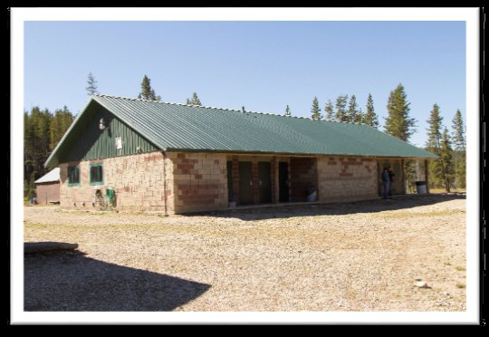

In 2008, construction began on a new shower house and restroom facility. Numerous volunteers contributed labor and materials to the effort. In the spring of 2010, the centennial anniversary year of the Boy Scouts of America, the new shower house was dedicated. The camp offers cafeteria-style meals to give troops more time for programming activities.
In 2021 the name was changed to The Bradley Scout Reservation by the Council board. This was done to reflect the increased opportunities available today.
In 2025 a total remodel of the Bradley Scout Reservation was undertaken by the Council. This included the addition of a new climbing tower, the complete remodel and upgrade of the Colly Parrish Lodge and the addition of a program shed and a ranger residence.
The Grand Pavilion was constructed on formerly unused area to serve as a centerpiece for programing. The Grand Son Pavilion was built as a home for the Outdoor Skills programing we are known for.
Further upgrades are coming and in progress. There are some areas of “Pardon our Mess”, but we are still building dreams.

Scoutmaster Leadership at Camp

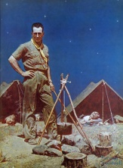
The Scoutmaster sets the example. Wear a complete uniform to morning and evening flag ceremonies to encourage your Scouts to follow your lead. Attend the daily 10:00 AM Roundtable; that is where you will get training and important updates and information about what is going on each day. The information provided will help you ensure your Scouts practice good fire safety.
If the Scoutmaster is unavailable to attend camp your troop committee must see that there is strong leadership for your troop at camp. The Scoutmaster in camp must be at least 21 years old. Assistant leaders must be at least 21 years old. While at camp, your troop must have always at least two on-site qualified adult leaders. Troops failing to meet this requirement will be assessed "Provisional Leaders" fees. (See Camp Fees, the cost is high intentionally to discourage this.)
The troop at camp should include its regular year-round leadership staff (adult and Scouts). Each patrol functions best when under its own leadership. The troop is run by the Senior Patrol Leader. The SPL is the key junior leader. The SPL should be well trained to carry out their camp responsibilities. They should attend the daily Senior Patrol Leader's Council meeting at 8:30 AM at the flag poles.

Volunteer Leaders Needed


Volunteer Camp Commissioner
We have need of FIVE Camp Commissioners each week of camp. Camp Commissioners will attend camp at half price if they sign up at the Scout Service Center before camp. When you volunteer at camp as a Camp Commissioner, you will get a camp T-shirt or maybe a patch.
They may be asked to help us develop new programs. These individuals will inspect campsites to meet Scout and Camp Standards as well as health and safety. Their units will also receive points towards being a Woodsman Honor Troop and Bull of the Woods.
Volunteer Camp Commissioners will be conducting daily campsite inspections with your Senior Patrol Lead (if he is available). Inspections ensure that campsites are kept safe and maintained in accordance with Outdoor Ethics principles. Results will be posted information will be posted on the bulletin board.

Assist Staff
We are always looking for leaders who would like to teach a merit badge during their week at camp. As we seek to improve the quality of our merit badge instruction and implementation.

Assist in Dining Hall
At every meal, we need leaders to volunteer to assist serving and cleaning up the dining hall. We will be asking at daily flags, and again before each meal. Every time you assist in the dining hall you earn points towards the Honor Troop Award.

Service Projects
We have many service projects that require adults and special skills to accomplish. Are you an expert in carpentry, building, plumbing, electrical or other specialized skills? Bring your tools and have fun with other adults by assisting in these types of projects. See the Service Corps 70 Section of this guide for more information

Pre-Camp Departure Check-List

- BSA Annual Health and Medical Record (Physicals) bring the correct physical signed by the appropriate person, please. All forms are to be turned in at the Monday morning check-in. Scouts and adults without the correct physical form cannot stay at camp and must obtain a physical or return home. See the current health form in the Appendix.

- Complete on-line merit badge pre-registration at least two weeks prior to your arrival at camp, with April as a target date, (but keep an eye on the website for updates) if you would like to ensure that your kids will get into the classes that they want. Please print and bring your Scouts’ merit badge schedules with you to camp, we don't have easy access to them at camp and your check-in will likely be delayed if you don't have them.

- Plan for Outpost/Special Events and after hour’s activities.

- Hold a parent orientation meeting with each camper's parent(s) and complete a list of personal emergency numbers to contact for each person.

- Camp registration completed at Council Office with all receipts.

- Complete a Troop Roster with age, Emergency Contact information with the first and last names of Scouts and scheduled adults who will be attending camp. Turn it into the Council Office at time of payment, or two weeks prior to attending camp and please bring a copy with you to camp.

- Neatly print completed Blue Cards for each merit badge a Scout will be taking before camp. There are Blue Cards available for sale at the Trading Post.

- Bicycle Helmets: Campers and staff members may use bicycles in camp. All bicycle riders must have a helmet on. A bike lock is recommended. Please take note and follow signage and rules of the road. STAY ON THE TRAILS.

Weather

The summer weather in Idaho’s central mountain area can be unpredictable. Warm, sunny days, sudden thunderstorms, rainy, drizzly days, and even snow flurries, are all common at Bradley Scout Reservation during the summer. Campers should be


prepared with adequate clothing, sunscreen, insect repellant, rain clothing, and other means of staying warm and dry. When packing always remember to:

Camp Fees

2024 Schedule of Camp Fees | Paid in full prior to April 1 | Paid in full prior to June 1 | Paid in full after  June 1
Scout Fee – In Council | $325.00 | $335.00 | $350.00
Scout Fee – Out of Council | $350.00 | $350.00 | $350.00
Adult Fee | $150.00 | $150.00 | $150.00
Provisional Leader Fee |  | $85.00/day
Meals if Purchased Separately
Breakfast and Lunch |  | $8.00 each
Dinner |  | $9.00 each

Other Costs 2026
Some Costs of materials for merit badges (Costs WILL vary slightly). All at Camp fees paid at Trading Post.

Item | Minimum Fee
Blue Cards | $ 0.20 each or $15.00 per 100
Art MB | $5.00 Art supply kit for paper and canvas etc.
Archery MB | $6.00 for an arrow kit
Basketry MB | About $16.00 for 3 project kits, natural materials can also be used
Leatherwork MB | About $ 15.00 for a merit badge kit
Rifle MB | $10.00 unlimited shooting/targets for merit badge class – Out of class $ 1.50 for 5 shots
Shotgun MB | Minimum $40.00 for shells and pigeons (50 rounds)
Woodcarving MB | About $3.00 for Neckerchief Slide kit, (sticks are free)
Indian Lore MB | About $15.00 for merit badge kit.
Wilderness Survival | $2.00 for safety glow sticks

T-shirts Pre-Orders
Camp T-shirts will be available at a discount if you order and pay for them prior to the April early pay deadline.

Refunds
To secure a campsite reservation, submit a completed reservation form and a $250.00 deposit per unit to the Mountain West Council Service Center. As an example, five troops would require a $1,250.00 deposit even if they all come to camp together to stay in the same campsite. This will hold a campsite reservation until the full payment is due. The deposit may be used toward the current year camp fees.
After the April early pay deadline all fee payments are non-refundable regardless of the situation. Fees are transferable to another youth in the same unit or units for whom the deposit was paid but are otherwise not refundable. The Mountain West Council must commit financial resources to employ staff, purchase food and supplies, and prepare for summer operations. Participants are required to make a financial commitment to attend. No refunds for items purchased at the Trading Post.

Necessary Items for Camp

Uniform and Attire at Camp


The official Boy Scouts of America field uniform is always appropriate dress at summer camp. Every camper and leader are expected to wear the “Class A” field uniform at evening flag assembly and dinner meals. The “Class B” uniform, substituting a Scout T-shirt for the uniform shirt, is encouraged at other times. (Leave the merit badge sash at home.)
Campers should wear sturdy walking or hiking shoes with socks. Lighter shoes may be worn in the campsite. Shower shoes (flip flops, sandals or shoes without toes, or with gaps or holes) should only be worn while in shower area.
Examples of inappropriate clothing might include; sleeveless undershirts; cutoff shirts or shorts; clothes with holes as a fashion statement; clothing with alcohol, tobacco or drug promotions, sexual references, vulgar, sexist or racist sayings, or gang insignia; and immodest swimsuits. Questionable or offensive tattoos must be covered.

Check List for Scouts at Camp
Below is a list to serve as a guide. Use your own discretion and refer to your Scout Handbook when packing for camp. Put in anything else that you think might help!

VERY IMPORTANT
- Signed Medical Health Form (required)
- Insect repellent
- Trading Post money $25 - $30
PERSONAL GEAR
- The Scout Basic Essentials (see Scout Handbook, Personal Camping Gear Checklist)
- Camera
- Camp Folding Chair
- Fishing gear
- Medications / eyewear
- Mess kit
- Notebook / pen / pencil
- Other gear for specific activities
- Pack
- Rain gear
- Scout Handbook / Merit Badge Books
- Totin’ Chip / Firem’n Chit
- Watch / alarm clock
CLOTHING
- FULL uniform (shirt, pants, belt, OA sash)
- Extra shoes / hiking boots
- Hat (day) stocking cap (night)
- Rain gear
- Shorts
- Socks (6 pair)
- Sweatshirt / jacket (see Weather)
- Swim trunks or one-piece swimsuits
- T-shirts (several)
- Underwear (6)
CAMPING GEAR:
- Cot or sleeping pad
- Sleeping bag & extra blanket(s)
- Pillow
- Foam pad (optional)
- Tent (each patrol must be sure they have enough tents to follow YPT tent guidelines)
Note: Camp Does Not supply tents, cots, or platforms.
CLEANUP KIT
- Soap / toothbrush / toothpaste / floss
- Comb
- Towel (at least 2)

Troop Equipment

Below is a list of general equipment needed at a long-term camp. Some troops may wish to bring other items to enrich their experience or to cook special desserts or snacks.
- All registration paperwork
- Advancement forms & record book
- Axe, hatchet & saw
- Bulletin board stuff & stapler or push pins
- Clipboards
- Clothes line / rope
- Cooking utensils
- Dining fly’s or canopy’s (especially nice should it rain)
- Dutch ovens, charcoal
- Firewood & matches (Please burn all wood that you bring or take it home with you.)
- Hammer, rake, and shovel
- Leader Specialty Tools for Service Projects
- Lock Box (for valuables & medicine)
- Merit badge book library
- Patrol, troop, and U.S. Flags
- Propane lanterns and stoves (if desired)
- Rope, twine or nylon cord
- Solid fire starter
- Tarps
- Tent repair kit, tools & duct tape
- Tents
- Trash bags
- Troop size first-aid kit

What Not to Bring to Camp



No pets of any kind, with the exception of certified service animals, are permitted in camp.

Do not bring alcohol, firearms, tobacco, fireworks, illegal drugs, video games.

Do not bring excessive grooming products, or other highly odorous products.
Pornography and other suggestive images are prohibited and are grounds for dismissal from camp, including clothing with inappropriate language or graphics will not be permitted.

ATVs or utility carts. Scouts/Leaders are permitted to use them as required for medical needs and with prior coordination with the Camp Director.

Camp Check in and Arrival

Check In is completed in the Parish Friendship Lodge. In order to affect a smooth and timely registration, all troops and participants should be in camp by 8:30 a.m., Monday morning. Sunday arrival is fine! Please call the Council office if you plan to arrive on Saturday. The first meal served to campers is Lunch on Monday at 12:00 pm
There will be no camp programs on Sunday.
Troops with proper paperwork i.e.: necessary receipts, paperwork, and physical exams will be able to sign into Camp very quickly.
Your first priority Monday morning is to get your troop to the aquatics area, even if you have already done swim checks. The Scoutmaster should come to the dining hall building for check in while your SPL and Camp Troop Friend will lead your troop to aquatics.

Swim Checks or Buddy Tags
If you are arriving Monday Morning Swim checks are available from 9 a.m. to 11:30 a.m. Your Scouts should have their suits available when you arrive. Units may do swim checks prior to arrival at camp if the BSA Swim Test for the unit were completed within the last six months and you bring a letter signed by a certified lifeguard, with a copy of the lifeguard’s credentials and contact information. No special form is required. A sample is provided in the Appendix. All Scouts must still report to the waterfront upon arrival to fill out buddy tags.
SPECIAL NOTE: Due to the depth of the water at the waterfront, we cannot do the diving requirements for the swimming merit badge. SPECIAL NOTE: The Camp Aquatics Director may choose to review or retest participants that appear unable to meet the proper standards for swimming in our cool and sometimes choppy lake. We want to make sure that we keep Scouts safe.

Flags and Kitchen Patrol (KP)
All troops will be assigned to participate at flag ceremonies with their troop and patrol flags. Scouts and leaders are expected to wear a Class A Scout uniform to flag ceremonies, and the breakfast and dinner meals are served following these ceremonies.
The flags and kitchen patrol assignments will be posted on the wall just inside the dining hall.

Camp Dining Hall
All meals at Bradley Scout Reservation are prepared by an excellent cook staff and provide a well-balanced, nutritious, kid friendly adult tolerable food served in the Parish Dining Hall. This allows Scouts to avoid the time-consuming process of preparing their own food and reduces the risk of bear encounters. The tasty large portions receive high marks from the campers each year.
Visitors may eat meals in the Dining Hall after purchasing individual meal tickets at the Trading Post.

Dietary concerns
Dietary concerns may be directed to the Camp Food Service Director at Camp. We have gluten free options available at each meal if advance notice is provided. We are a gluten friendly camp not gluten free. If a Scouts’ dietary restrictions are so significant that they cannot eat what is on the menu, the unit should have a dedicated leader assist in preparing the meals for the Scout. Refrigeration space will be made available to the leader. Our Kitchen Staff is not able to prepare individual meals.

Special Needs the BSA respects the desire of all youth who are willing to abide by the membership standards to participate in our programs. Staff are committed to delivering camp programs to individuals with special needs.

Contact Information – Bradley Scout Reservation



Important Phone Numbers

Camp Registration

Scout Service Center
(208) 376-4411

Emergency Contact Information
If parents need to contact you or a Scout for an emergency while you are at camp, please provide the following emergency contact list to them. When contacting a person at camp in case of emergency, please provide the name of the Scout, their Troop number, campsite if you know it, and Scoutmaster’s name.

Camp Director Phone Numbers
R.D. Hill
Camp Director
Cell Phone # (208) 703-5474

Bradley Scout Reservation - Emergency Only Phone Number
254-381-7534

Mountain West Council, Boise, ID
Lynn Gunter
MOUNTAIN WEST COUNCIL Scout Executive
Scout Service Center
(208) 376-4411

Correspondence
You may like to write to your youth while they are at camp. If you want to ensure they will receive the letter while at camp you will need to send it on Monday, or the same day that they depart for camp. Alternatively, give it to the Scoutmaster to pass to us for delivery.
For your Scout to receive a letter at the last mail call at camp, Friday evening at 5 pm, a letter would have to have been received and processed at the Stanley Post Office by 10 am Friday morning. Any mail received after the troop has checked out will be returned to the sender. Please plan.

Our mailing address is:


Bradley Scout Reservation
Scout’s Name, Troop #__
P.O. Box229
Stanley, ID 83278



Bradley Scout Reservation
Does not have FedEx or UPS service.

NOTE: “Post Cards” rarely arrive while Scouts are at camp because they are 3rd class mail and go space available.

Outgoing Mail
Outgoing mail may be placed in the mailbox in front of the Trading Post. Mail is taken to the Post Office three times a week. Incoming mail will be available only to unit leaders and or is handed out at daily mail calls after the evening flag ceremony.

Camp Rules

Everyone at Bradley Scout Reservation is expected to speak and act in accordance with the Scout Oath and Scout Law. In addition to the guiding principles found in the Scout Oath and Law, the following rules have been developed in accordance with the policies of the Boy Scouts of America and/or the laws of our state and country.
These RULES must be enforced for the safety and security of all. We ask for your cooperation and support in observing these, Rules. Failure to do so may mean your unit or an individual may be asked to leave camp. If one of these Rules is violated and you are asked to leave camp, you will not receive a refund.

Checking In and Out of Camp
All unit leaders must check at the CAMP OFFICE when arriving at camp. There may be health and safety concerns to discuss. Units or Scouts should not proceed to Camp Sites without the Scoutmaster checking in.
Individuals are not allowed to leave camp without the permission/knowledge of the Camp Director (this is because if we must evacuate camp for any reason like a forest fire, etc., we need to account for each person). If you need to leave camp, please check out and back in, at the Trading Post.

Buddy System
All Scouts are expected and required to use the buddy system at camp, even when in your own campsite.

Safeguarding Youth
Youth Protection is always a major concern. Youth members must not in any way be abused by any adults or other youth. Violators will be reported to Child Protective Services or local law enforcement and be immediately removed from camp.

Off Limit Areas
Specific areas of camp such as the waterfront are off limits unless adult supervision is available. All program areas are off limits except when open for merit badges or special programs.
Campers are not allowed in the staff area at any time. This includes warehouse, shop, ranger home, staff tent city, staff housing and staff parking area.
Campers may not enter any campsite of other units unless invited by the unit and the Unit leader should be present. Any area that may be flagged with warning tape is not to be entered.

Fires in Camp
Bradley Scout Reservation is located in a National Forest and parts of our operation are conducted on Forest Service land. Both Camps follow fire regulations established by the BSA, US Forest Service, and local fire service areas.
- To minimize fire risk, please use battery-operated lights and lanterns as much as possible.
- Campers should strictly observe BSA’s standard for no flames in tents.
- Fires are restricted to designated fire pits and should remain small.
- Each troop will be given a Fireguard Chart which should be posted visibly on the bulletin board in camp. According to Fire Guard Standards, buckets of sand and water should be outside each tent and by the campfire.

Knives
At Camp, folding pocketknives are preferred over fixed-blade knives. “A sharp pocketknife with a can opener… is an invaluable backcountry tool. Keep it clean, sharp, and handy. Avoid large sheath knives. They are heavy and awkward to carry, and unnecessary for most camp chores except for cleaning fish” (Guide to Safe Scouting). As a general rule, most everyday knives with a blade up to approximately 4 inches in length will be acceptable for use. Folding knives with a quality blade lock are preferred. Multi-tools are excellent tools at camp. Check with the Camp Commissioner if you have questions about a particular knife.

Axes - Hatchets
Axes and hatchets are approved for use at camp in designated ax yards only. These tools should not be used to cut, chop, carve, or otherwise harm living trees. All uses of cutting tools should adhere to the principles of Outdoor Ethics.

Fighting
Fighting and causing physical harm to anyone is not an acceptable way of handling differences. Unit leaders and those involved in the situation will Council with the Camp Director to determine a course of action.

Theft in Camp
Theft in camp is always a concern. Anyone caught stealing from others will be removed from camp immediately and turned over to local law enforcement. Theft from a tent in Idaho is considered a Felony.

Vehicles in Camp
Please remain on established trails and roads. The vegetation at camp is very delicate and straying from established trails may cause damage that takes years to repair.
All vehicles must be parked in the parking lot and not in the campsites, unless approved by the Camp Commissioner. Please back vehicles into spaces and have your keys with you at all times in case of fire or other emergency evacuation orders. (“Getaway” position pull-out is 30% more efficient in an evacuation.) A vehicle identification form is located in the appendix and should be visible on the dashboard in the front windshield of all vehicles entering camp. Fill it out using a medium “Sharpie” type marker.

Leaders are not allowed to park cars or trailers at campsites without Permission from the Camp Commissioner. Camp Commissioner will ensure that trailers and vehicles do not block trail access in any way to campsites and are out of the way for camp vehicles to have unobstructed access for maintenance of camp facilities.

Chainsaws
The use of chainsaws may only be authorized by the Camp Ranger and only for trained adults using proper protective gear.

Bicycles at Bradley Scout Reservation
Bicycles may be used in approved areas in camp. However, in the common areas, bikes should not be ridden but walked through the area. Bikes may be used to travel to and from the lake and in other areas outside of camp. Bicycle privileges may be lost for violations of the following rules:
• A helmet must be worn when riding. If a Scout does not have a helmet, they should not ride a bike.
• Riders may only travel at reasonable and safe speeds in a manner that is respectful to nearby pedestrians, facilities, and natural resources.
• Bicycles may only be used in accordance with Forest Service regulations on designated roads and trails.
• Bicycles should be parked in designated areas.
• Gas powered motors attached to bicycles are prohibited.
• Bradley Scout Reservation, the Mountain West Council and the Boy Scouts of America are not responsible for damage or loss of bicycles at camp.

Firearms – Ammunition – Weapons – Bows and Arrows
Adults and youth are prohibited from having firearms, ammunition, bows and arrows, or other weapons in their personal possession on Camp property. If unauthorized firearms are found, they will be confiscated by the camp director, safely secured, and returned at check-out.

Alcohol - Illegal Drugs - Tobacco
Bradley Scout Reservation is 100% alcohol-, illegal drug-, and tobacco-free camp. The Boy Scouts of America prohibit alcoholic beverages at youth events and on BSA properties. This applies to properties surrounding BSA camps where program events for youth are offered. Youth members of the BSA are not permitted to use tobacco in any form. Adults are only permitted to use tobacco in designated areas away from Scouts and camp activities. Contact the Camp Director or Camp Commissioner about these designated areas.

A Scout Is Clean-Showers
Camps have hot-water showers available to youth and adults in the central shower house. Pit toilets and cold-water hand-washing stations are scattered around camp (closer to campsites).
Each Scout who attends camp is expected to wash their hands often and before meals. Scouts are to shower regularly throughout the week. Troops are encouraged to assist in keeping the shower and restroom facilities clean and sanitary.
Separate posted shower times for adults and youth participants as well as those of different sexes must be adhered to by everyone while at camp.

Damage to Camp Property
Anyone causing damage to camp property either intentionally or accidentally will be expected to pay for the damage. Repairs will be assessed at the cost of supplies and $50/per hour labor.
Any person maliciously harming or killing local wildlife will be turned over to the appropriate law enforcement agency and the parent/guardian contacted immediately.
Intentional damage or harm is grounds for expulsion from camp.

Insurance Coverage for Volunteers

Listed below are brief outlines of insurance coverage provided by or through the Mountain West Council and the Boy Scouts of America. (Please note these are not legal descriptions, and generally accurate and only for information purposes. If you have specific questions about policies and coverage you will need to contact the appropriate insurance company with your specific details.)

Comprehensive General Liability Insurance
Liability coverage is to cover you as leaders should you be sued by a parent. It does not cover medical expenses.
This coverage provides protection for the Council, all Scouting professionals and employees, Scout units, chartered organizations, and volunteer Scouters (whether registered or not registered) with respect to claims arising in the performance of their duties in Scouting. Coverage is more than adequate for bodily injury and property damage.
The insurance provided to Scouting volunteers through the BSA General Liability Insurance program is excess over and secondary to any other insurance the volunteers might have to his or her benefit, usually a homeowners, personal liability, or auto liability policy. There is no coverage for those who commit intentionally negligent or criminal acts.
By providing insurance coverage to volunteers on an excess basis, BSA is able to purchase higher limits. Because of the high limits, volunteers should NOT be placed in a position where their assets are jeopardized because of a negligence liability claim or lawsuit.

Automobile Liability Insurance
You need to carry limits as specified by your state of residence. (This is also not Medical/Accident Insurance coverage!)

Unit Accident Insurance Plan
Unit accident insurance forms are provided through the Council. This coverage plan is secondary coverage. That is, the parents’ insurance is primary, this insurance covers the Scout(er) when the parents do not have insurance; it may also cover a deductible. These plans provide coverage for accident medical expenses while participating in any approved and supervised Scouting activity, including going to and from meetings. New members are automatically covered under the plan until the renewal date. Non-Scouts attending scheduled activities (including group travel to and from these activities) for being encouraged to participate in Scouting are also automatically covered. However, this plan does not cover parents, siblings, or other guests. PLEASE REPORT ALL SERIOUS INCIDENTS, ACCIDENTS AND SICKNESS AT CAMP TO THE CAMP DIRECTOR IMMEDIATELY.

Camp Programs

Establishing Your Unit Camp Program Plan Before and At Camp

Merit badges classes vary by the length of time needed to meet National Camp Standards and difficulty of the material to be covered. Merit badge sessions from one to three hours, or longer when outposts are involved. Merit Badges also vary by the number of times they are offered daily.
To have a Merit Badge signed off; each Scout must pass a written/practical and/or an oral examination. Care must be taken not to allow Scouts to over schedule classes or have overlapping times. Scouts should also consider travel time between program areas so arrival at merit badge sessions is always on time. It may be necessary that Scouts skip a session. Scheduling classes with the Scouts using the Tentaroo program before camp is vital to ensure Scouts have the best possible experience at camp.
At Camp meet with your SPL each morning to go over the day’s activity plans for the troop and each patrol; follow up with the SPL each evening to review the events of the day. Make sure the SPL understands how to work the plan.
When you follow these Guidelines, you will create a large number of opportunities for your Scouts to practice and exercise their leadership. You will help each Scout assume responsibility for the accomplishment of their personal goals.

Ensure your SPL attends daily 8:30 SPL meetings at Flag Poles and Briefs the Troop. Scoutmaster and SPL should meet at lunch and then brief Troop on schedules and updates on activities and Camp Policies.
We hope that you and your Scouts will accomplish all of the things your troop sets out to do at summer camp this year. We trust that your troop will be able to leave camp stronger, better trained, and more enthusiastic than ever before. Please take the time to carefully plan your troop’s summer camp program with your Troop Leader Council, so that the wildest expectations of your Scouts can be realized this coming summer.
Merit badges are a part of Scouting for three reasons. First, they encourage youth to increase their skills in things. Second, they challenge youth to try out new activities that may result in fresh interests or hobbies. (One of these may even start them on a path to a career.) Third, they encourage association with adults to prepare them for the future.
The success of your camp program must not be measured in terms of the number of badges earned but should be measured on how much FUN and new skills Scouts experience, and how the Troop and Patrols function as a team.
Remember, this is a SCOUT led process. Be in contact with their SPL when you feel your counsel is needed, help them and the Patrol Leaders keep their Scouts on track.
Scoutmasters, Leaders, and Senior Patrol Leaders are encouraged to ensure all Scouts have access to and read the most current Merit Badge Books before camp to make completing merit badges easier. All Merit Badge Books offered at BSR are available at the Council Stores. Most merit badge books have been released, and are online.

Camp Awards

Honor Troop Award
The Honor Troop who demonstrated the highest ideals of Scouting while attending camp and has the most points may earn the Honor Troop Award, only one Troop per week. Even when Troops are sharing a campsite. Only one troop will be chosen per week. Please note that points alone will not earn a troop, the Honor Troop Award. Troops must demonstrate an understanding of the Scout Oath and Law while earning their points; that is the key!

Soaring Eagle Troops
We have learned over the years that there are many Troops that deserve special recognition for their service, performance, and participation at Camp. While only one Troop that achieves the status of Bull of the Woods, the Camp Commissioner will now recognize outstanding Troops weekly by awarding them the Camp Soaring Eagle Troop Award.

Quality Troop Awards
Quality - Troop demonstrates the ideals of Scouting while attending camp. All units who earn at least 300 points may earn the Quality Troop distinction.

Spirit Stick
The Spirit Stick is a long-standing tradition at Camp. It is passed daily from troop to troop at flag ceremonies. Troops that hold the Spirit Stick should embellish it with a totem of their choosing. Totems should be Scouting appropriate and reflect the values and standards of Scouting.

Quality Troop Award Form
This Form is to be filled out by Senior Patrol Leader and Scoutmaster
Troop __________ Campsite_______________ Form Completed for each Troop in Shared Sites.  Requirements | Possible Points | Points Earned
Campsite Inspections – Daily Possible (Commissioner Completes this Box) | 240
Leadership AND Campsite
SPL present at daily SPL Meeting (with the Program Director at 0830 at the Flag Pole), 1 point for each of 4 meetings attended (If all meetings attended, points are doubled to 8) | 8
Scoutmaster present at all 3 PM Roundtable Meeting | 50
Trash picked up every night or removed to bear proof cans the night before and no trash in garbage cans. | 40
Troop Campsite Programs
Flag Ceremony – Daily (1-point x 4 days) | 4
Invite at least two other troops to a flag ceremony at your campsite | 20
One well planned Troop Campfire Program At least 15 minutes long: must include patrol skits, run-ons, songs or cheers | 10
One story & Scoutmaster’s Minute and have at least two other troops attended | 10
Invite at least one other troop to an Inter-Troop Activity, such as a game | 10
Camp-wide Program Participation
At least 50% of troop is in full uniform at flag ceremonies | 50
Entire troop in full uniform at ceremonies | 100
Raise or lower colors during Camp-wide Flag Ceremony | 10
Provide K.P. for at least one meal during week (Entire Troop and Leaders stay to complete) | 10
Be selected to provide a skit or a song for the closing campfire | 10
Have adult leaders volunteer to serve meals (each time is 1 point per adult per meal) max | 50
Have a unit leader act as a Volunteer Commissioner at camp | 25
Participating in Cape Horn Challenge | 10
Participate in Polar Bear Swim (At least 75% of Scouts in Troop) | 10
Stay on a troop outpost camp. | 10
Camp Service and Conservation Projects
Troop Campsite Improvement by Scouts: ______________________ | 10
Troop Camp Service Project by Scouts: ______________________ | 20
Adult Service Project for Camp Commissioner or Ranger: _______________ | 10
Nature Area Conservation Area Service Project: _____________________ | 10
Total

Leader’s Activities at Camp

When you come to camp, we hope you come to have a little fun and some time off from the outside world. Some fun activities planned for you may make this a fun experience for you as well. If you complete the events, you may be able to win some of our awards for Scout Leaders.

Leaders Daily Training at Roundtable:
Safe Swim Defense and Safety Afloat Training; Climb on Safely Training; and others will be offered.

Leaders’ vs Scout Archery Score
Come to the archery range and bring your best eye. Shoot off against your Scouts for bragging rights and good fun.

Changes at Mountain West Council, BSA Scout Camps

2023- Trail to First Class was reinvented to be presented in a full block format that allows for more time on basic Scout skills and advancement opportunities. This is now known as the “Tapawingo Adventure”

Community Group Support of Mountain West Council Camps

2025 Overhaul of camp. The council has provided us with a comprehensive overhaul of the Bradley Scout Reservation. This includes: the grand pavilion, the grandson pavilion, the new dining hall, new gazebos in the campsites, a new program storage shed, new ranger house, and the crown jewel of the new climbing tower.
2018 the National Rifle Association of America, Idaho Friends of NRA State Fund Committee granted Camp Morrison a generous grant of ammunition, shotguns, rifles, clay targets, an Atlas AT-250 Standard clay thrower, archery targets, Easton Genesis Arrows, and safety equipment. This generous grant continues to benefit our shooting sports program. Please show your appreciation by participating in the Friends of the NRA Banquets held near you annually.
2010 - 2017, A Capital City Kiwanis Member gifted 13 new Canoes
2010 - 2017 the Idaho Automatic Weapons Collector’s Association donated 11 new Savage Mark I-FVT with aperture sights, Thank you I.A.W.C.A.!
2016 A generous donor from Troop 77 purchased 20 new bows!
2016 Pheasants Forever provided a new automatic Trap for the Shotgun Range!

APPENDIX

Order of The Arrow

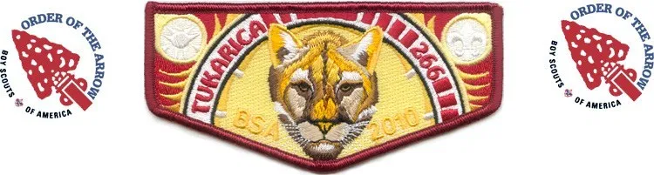

Tukarica Lodge #266
The Order of the Arrow is Boy Scout's National Honor Society, with a membership of more than 176,000 Scouts and Scouters. The OA is run by elected Scout leaders assisted by adult advisers. Its purpose is to recognize those Scouts and adult campers who best exemplify the Scout Oath and Law in their daily lives; to develop and maintain camping traditions and spirit; to promote Scout camping; and to crystallize the Scout habit of helpfulness into a life purpose of leadership in cheerful service to others.
Tukarica Lodge 266 is chartered through the Ore Ida Council of the Boy Scouts of America, and is headquartered in Boise, Idaho.
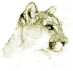
The totem of the Lodge is the Cougar and the name Tukarica comes from the Shoshoni, literally meaning Sheep-Eater (Cougar).
The Lodge and its members contribute thousands of work hours each year to the Council and its various communities through individual and group service projects.
The Lodge provides service to the Council Camps by holding Ordeal Inductions to help open and close the camp every year.
Annually you have the opportunity to hold an election to honor those members of your troop that meet the eligibility requirements.
More information about the Order of the Arrow may be obtained through any member of the Camp Staff.

Eligibility:
- Spend 15 nights camping while registered with a troop, crew, or ship within the previous two years, including at least one (but no more) long-term camp consisting of at least five consecutive nights of camping.
- At the time of their election, Scouts must be under the age of 21, hold the Scouts BSA First Class rank or the Venturing Discovery Award, be approved by Scoutmaster, and be elected by the Scout members of their unit.
- One registered adult 21 or older who meet the camping requirements may be selected annually from each unit.

The Lodge and its members contribute thousands of work hours each year to the Council and its various communities through individual and group service projects.
More information about the Order of the Arrow may be obtained through your Staff OA Adviser.

Medical Risk Factors for Your Participation in Scouting

Medical Risk Factors for Your Participation in Scouting
Scouting can be physically and mentally demanding. To help its members be better prepared, the Boy Scouts of America recommends that everyone who participates in a Scouting activity have an annual medical evaluation by a certified and licensed health-care provider: a physician (MD or DO), nurse practitioner, or physician assistant. Based on the vast experience of the medical community, the BSA has identified risk factors that could become issues during weekend camping, hikes, treks, tours, or other activities.
Become familiar with the following risk factors to ensure all Scouts and Scouters are prepared.

Excessive Body Weight (Obesity)
Excessive body weight increases risk for numerous health problems. To ensure the best experience, Scouts and Scouters should be of proportional height and weight. One such measure is the Body Mass Index (BMI), which can be calculated using a tool from the Centers for Disease Control here: www.cdc.gov/nccdphp/dnpa/bmi/. Calculators for both adults and youth are available. It is recommended that youth fall within the fifth and 85th percentiles. Those in the 85th to 95th percentiles are at risk and should work to achieve a higher level of fitness.

Cardiac or Cardiovascular Disease
These include:
- Angina (chest pain caused by blocked blood vessels or coming from the heart)
- Myocardial infarction (heart attack)
- Heart surgery or heart catheterization (including angioplasty to treat blocked blood vessels, balloon dilation, or stents)
- Stroke or transient ischemic attacks (TIAs)
- Claudication (leg pain with exercise, caused by hardening of the arteries)
- Family history of heart disease or a family member who died unexpectedly before age 50
- Smoking
Youth who have congenital heart disease or acquired heart disease such as rheumatic fever, Kawasaki’s disease, or mitral valve prolapse should undergo a thorough exam.

Hypertension (High Blood Pressure)
Scouts and Scouters should have a normal blood pressure (less than 140/90). Persons with significant hypertension should be under treatment and their condition should be under control. If participating in a Scouting event that is physically demanding, it is recommended that hypertension be under control in the six months prior to the date of the event. The goal of the treatment should be to lower blood pressure to normal levels. Those already on antihypertensive therapy with normal blood pressures should continue treatment and should not choose the time they are at any Scouting event to experiment with or change medications.

Diabetes (Insulin-Dependent Diabetes Mellitus)
Any individual with insulin-dependent diabetes mellitus should be able to self-monitor blood glucose and know how to adjust insulin doses based on these factors or be accompanied by a guardian that is knowledgeable in these matters. The individual with diabetes and/or the guardian should also know how to give a self-injection/injection and recognize indications of high and low blood sugar. If planning on participating in an overnight experience of any kind, bring enough medication, testing supplies, and equipment for the entire Scouting event. This includes batteries (without provisions for recharging) to be both brought to and taken away from the event for pumps (remember Leave No Trace guidelines).
An insulin-dependent individual who has been newly diagnosed (within six months of the fitness examination) or who has undergone a change in delivery system (e.g., an insulin pump) in the same period and who desires to participate in a Scouting event that is physically demanding should reconsider participation. This also applies to an individual who has been hospitalized for diabetic ketoacidosis or who has had problems with hypoglycemia in the last year.

Seizures (Epilepsy)
Seizure disorder or epilepsy should be well-controlled by medications if an individual desire to participate in a physically demanding Scouting event. A minimum of six seizure-free months prior to the fitness examination is considered under control. Participants with a history of seizures need to limit high-adventure activities (e.g., climbing or rappelling).

Asthma
Acute or severe bronchial asthma under treatment anytime during the past 24 months should be well-controlled before participating in physically demanding Scouting events. Key indicators of well-controlled are:
- The use of a rescue inhaler zero times to one time a day
- No need for nighttime treatment with a short-acting bronchodilator
- Well-controlled asthma may include the use of long-acting bronchodilators, inhaled steroids, or oral medications such as Singulair.
- If the Scouting event is physically demanding, individuals with the following asthma conditions should reconsider participation:
- Exercise asthma is not prevented by medication.
- Participant has been hospitalized or has gone to the emergency room for asthma treatment in the six months before the fitness examination.
- Participant has received treatment that required oral steroids (prednisone) in the six months before the fitness examination.
- When participating in any overnight Scouting event, participants must bring an adequate and a backup supply of medications and spare rescue inhalers that are current. Participants must carry a rescue inhaler at all times during any Scouting event.

Sleep Apnea
Scouts and Scouters with sleeping disorders may experience health risks due to long days and short nights for many Scouting events. It is recommended for those with sleep apnea requiring a CPAP machine for any overnight Scouting experience that all equipment (e.g., CPAP machine) be provided by the Scout or Scouter and be self-contained. This may include batteries (without provisions for recharging) to be both brought to and taken away from the Scouting event (remember Leave No Trace guidelines). The Camp Commissioner can make arrangements for recharging your CPAP machines.

Allergies or Anaphylaxis
Scouting events have several risks (e.g., nuts, pollens, wasps, hornets, and other stinging insects) that could trigger anaphylactic reactions in individuals prone to reaction. It is recommended that Scouts and Scouters who have had an anaphylactic reaction from any cause contact the appropriate medical personnel of the Scouting event to confirm participation eligibility before arrival, especially if the event includes an overnight experience. Participants will be required to have appropriate treatment with them at all times.
For longer Scouting events such as summer camp, jamborees, and high-adventure programs, allergy shots required for maintenance doses may be acceptable for persons who have not had an anaphylactic reaction. Contact the appropriate medical personnel for the event for confirmation.

Ingrown Toenails, Recent Musculoskeletal Injuries, and Orthopedic Surgery
Many Scouting events put a great deal of strain on feet, ankles, and knees. If the Scouting event is physically demanding, ingrown toenails should be treated within a month prior to the event. Scouts and Scouters, who have had orthopedic surgery,
including arthroscopic surgery, or significant musculoskeletal injuries, including back problems, should have a release from the surgeon or treating physician to participate in Scouting events.

Mental, Emotional, Social, Health. (MESH)
Psychiatric/psychological and emotional disorders do not necessarily exclude an individual from Scouting events. Parents and advisers should be aware that most Scouting events are not designed to assist in overcoming psychological or emotional problems and may exacerbate existing conditions. Experience demonstrates that these problems frequently are magnified, not lessened, when participants are subjected to the physical and mental challenges of many Scouting activities.
Any condition must be well-controlled without the services of a mental health practitioner. Under no circumstances should medication be stopped before or during a Scouting activity. If the Scouting event is an overnight experience, Scouts and Scouters are required to bring an appropriate supply of medication for the duration of the event, including travel to and from the event.

Other Risk Factors
Sickle-cell anemia, hemophilia, leukemia, severe blood dyspraxia, and HIV infection provide special challenges to Scouts and Scouters. To plan for, prepare for, and support those having these medical conditions, it is recommended that an individual evaluation of each situation be done by the appropriate medical personnel. There may be instances where proper medical support at the Scouting event is impossible. Under such circumstances, participation may be denied. For information on any other health issues, contact your personal health-care provider.

BSA Health Report and Medical Record

There’s A New Updated Annual Health and Medical Record to Use (2019 printing)
Every few years, the BSA updates its Annual Health and Medical Record after consulting with health care professionals, Scout executives, council and camp health officers and other experts to ensure it is up-to-date and helpful.
This was one of those years, meaning a new form is available for everyone to use for 2021. Your AHMR is valid through the end of the 12th month after the date it was administered by your medical provider. For example, if you got your physical on Nov. 3, 2020, it’s valid until Nov. 30, 2021.
Next year will be a transition year, so you can use either the old or new form, but everyone in all Scouting programs must use the updated AHMR form starting Jan. 1, 2021. The old form will be obsolete at that date. The BSA recommends using the new form on your next physical exam or if you’re a new participant in 2021.
Since at least the 1930s, the BSA has required the use of standardized health and medical information. The last time this form was updated was in 2014. The changes made this year were minor, such as some conditions listed in the health history section.
You can download the new form from the BSA at https://bit.ly/3Sh8WRV The Annual Health and Medical Record is required for Scouts and adult leaders who want to go on Scouting events, campouts and high-adventure trips. Note that there are different parts to the AHMR:
Part A is an informed consent, release agreement and authorization that needs to be signed by every participant (or a parent and/or legal guardian for all youth under 18).
Part B is general information and a health history.
Part C is your pre-participation physical exam completed by a certified and licensed health care provider.
Which part must be completed?
For all Scouting events: Part A and B. Give the completed forms to your unit leader. This applies to all participants for all activities, day camps, local tours and weekend camping trips less than 72 hours.
For events or camps: Part A, B and C. A pre-participation physical is needed for resident, tour, or trek camps or for a Scouting event of more than 72 hours, such as Wood Badge and NYLT. The exam needs to be completed by a certified and licensed physician (M.D. or D.O.), nurse practitioner or physician assistant. If your camp has provided you with any supplemental risk information, or if your plans include attending one of the four national high-adventure bases, share the venue’s risk advisory with your medical provider when you are having your physical exam.
For high-adventure trips: Part A, B and C. Plus, each of the four-national high-adventure bases (Florida Sea Base, Northern Tier, Philmont and the Summit Bechtel Reserve) has provided a supplemental risk advisory that explains in greater detail some of the risks inherent in that program. Please review these as some Scouts or leaders may not be physically or mentally able to handle the trek. Others arrive at a high-adventure base without discussing that base’s risk factors with their health care provider, meaning they have missing info at check-in that can slow down the process.
How do I fill it out?
Please review and complete the Annual Health & Medical Form fully and carefully. If you have any questions how to review it, read this BSA Safety Moment www.scouting.org/health-and-safety/safety-moments/how-to-review-the-ahmr/ or look at these frequently asked questions www.scouting.org/health-and-safety/ahmr/medical-formfaqs/. Remember, these completed forms must be secure, so they are not to be digitized, scanned, emailed or stored electronically by unit leaders.

Daily Campsite Roster

Campsite: _________________________________________ Troop: ____________

Print Neatly! Each Daily Item has a buddy team to accomplish the assigned task.

 | Trash  Removed | Latrine  Cleaned | Campsite Litter Control | Campsite Flags | Water Tender | Fire Ring Maintenance
Monday
Tuesday
Wednesday
Thursday
Friday
Saturday
 | Place trash bags on road by 9:00 PM and/or take to bear proof cans if more food waste -including candy wrappers- if time missed of more trash developed-including candy food wrappers. | Hose down each day, pick up trash & Litter in and around latrine building | Police the entire campsite for trash daily. Before Morning Flags. | U.S. Flag posted. Troop flag posted or brought to Parade Ground for ceremonies. | Water barrel, fire cans, and troop water jug filled. Hose coiled properly. (Hose is not a tripping hazard) | Remove any burned trash from fire ring. Reburn large logs or put in ax yard.

Senior Patrol Signature: ___________________________________ Date Posted on Bulletin Board______________

Early Camper Release Form
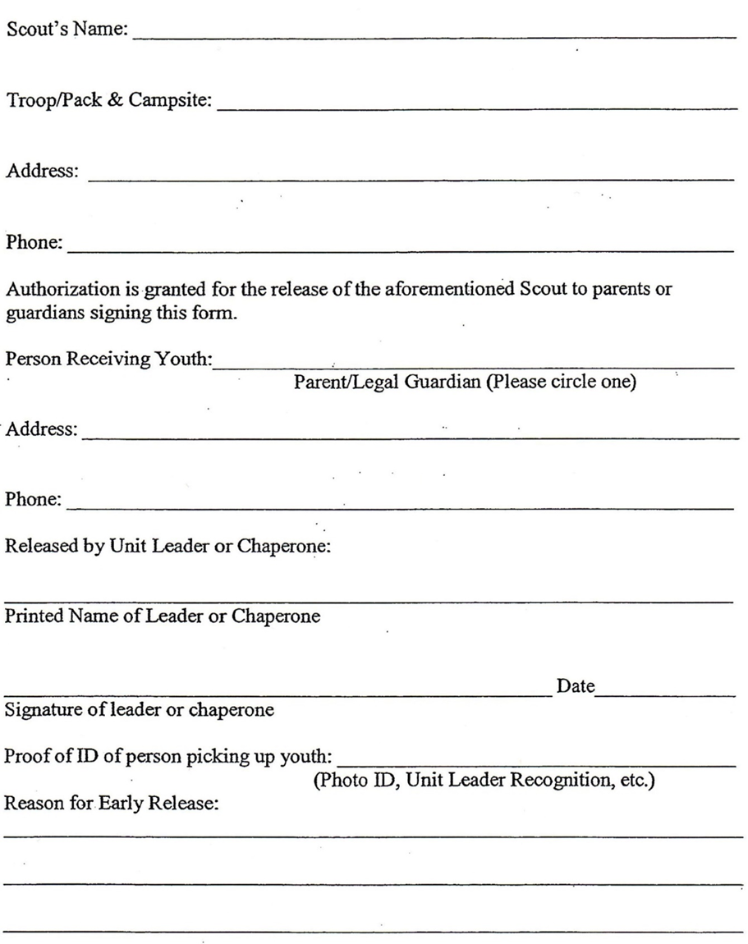

Camp Check Out Form

Week: ______ Troop: ______ Campsite: __________________________

Name of Staff Checking Out Site: ____________________________________________

Senior Patrol Leader should ensure that the following are completed before Camp Staff completes this form.
- All campfires extinguished and COLD TO THE TOUCH
- Place burnt logs in the Ax Yard
- Remove any and all trash from the campfire ring
- Fill fire ring with water (if needed) and scatter ashes deep into the woods or if bagging the ashes do not overload trash bag(s).
- Please leave Water Fire Barrel full. (We had them dumped in the past but not anymore.)
- All Fire Buckets are empty and neatly stacked near the Water Barrel.
- Permanent improvements including gateways, campsite sign, Bulletin Board, ax yard etc. are left standing.
- Trash barrels are empty. Place the filled trash bags on the inner camp service road.
- Ensure all micro trash is removed from in and around campsite.
- Latrines have been hosed down seats cleaned and lids down.
- Make sure that the micro trash is picked up inside and around the building.
- Coil the hose.
- All vehicles, tents, packs and other gear have been removed from campsite.
- Signs on bulletin board and in Latrines are proper and in good condition. (Standard signs in place–Troop’s signs are removed.)

Once the campsite is cleared and all Scouts and equipment, Troop members (adults and Scouts) may not leave camp until check-out is completed, including the items below:
- Returned this form to the Check Out Station at the Parade Ground by Staff Site Inspector and Scoutmaster to Complete Check-Out
- Check Lost and Found (in front of the Trading Post) for any found items.
- Settle any balance of additional camp fees or Trading Post charges at the Check Out Station.
- Pick up medical forms and any stored medicine from the Health Lodge.
- Pick up the troop’s Camp patches.
- Signature of Staff Campsite Inspector: _______________________________________________________

Campsite Concerns: ______________________________________________________________________________________________________________________________________________________________________________________________________________________________________________________________________________ More comments on the back of this form.

Make sure upon leaving the campsite that it is ‘MONDAY MORNING READY’ for the next troop. Please leave the campsite better than you found it.

Thank you for choosing Bradley Scout Reservation for your summer camp experience.

LEAVE NO TRACE

Mountain West Council Camps -Troop Roster – Scouts BSA
Troop Number: _____________________ Council Name: _____________________
Camp Week: _______________________ Camp Site: ________________________
Scoutmaster in Camp ( I have Completed Scoutmaster Training)
Name: ____________________________________ Phone: (________) __________________
Address: ______________________ City: _______________________ State: _______ Zip: _______
E-Mail Address: __________________________________
Assistant Scoutmaster in Camp ( I have Completed Scoutmaster Training)
Name: ____________________________________ Phone: (________) __________________
Address: _______________________ City: _____________ ________ State: _______ Zip: _______
E-Mail Address: __________________________________
Member ID# | Scout’s Name | M/F | Age | Emergency Contact | Phone Number
 | Additional Leaders Name

Scouts must be registered with the Council/BSA and have Member ID by the first day of camp to participate.

Sample Swim Test Form and Procedures

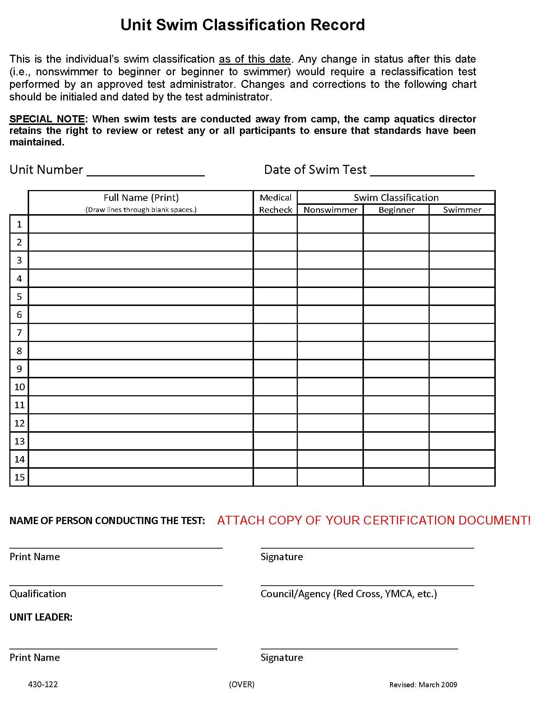

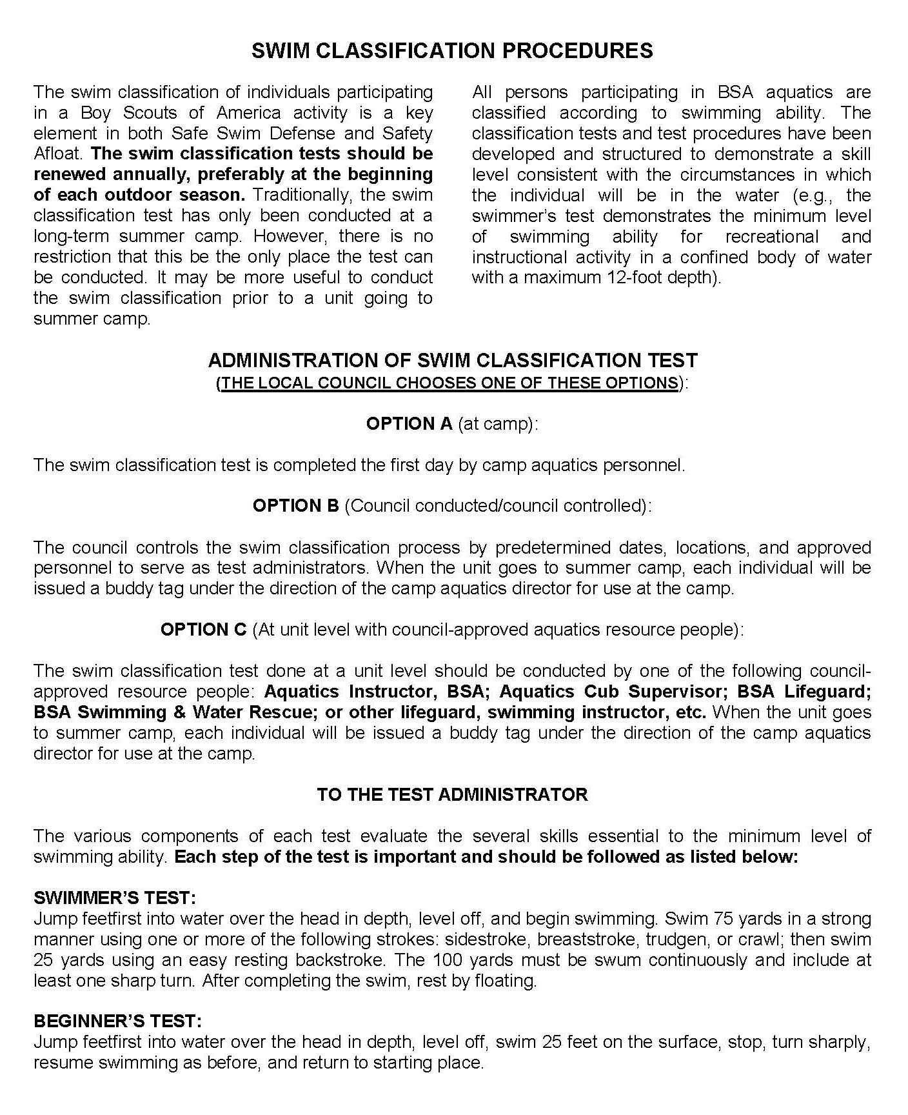
For Requirement 7 of Swimming Merit Badge certify, the Scout did the following:
Following the guidelines set in the BSA Safe Swim Defense, in water at least 7 feet deep, show a standing headfirst dive from a dock or pool deck. Show a long shallow dive, also from the dock or pool deck.

BSA Complete Angler Award

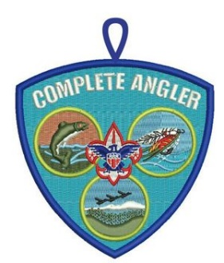
Earning the BSA Complete Angler Award could help you expand your fishing knowledge and experiences.
To become eligible for the award, start by earning these three merit badges: Fishing, Fly-Fishing, and Fish and Wildlife Management.
Then complete one or more of the following projects:
- Teach a Fishing or Fly-Fishing merit badge skill to your troop, crew, or team as part of a unit program activity.
- Help instruct Cub Scouts on fishing skills or fishery management as part of a Cub Scout meeting or outing.
- Participate in a local fishing derby or tournament, either a Scouting or community event.
- Complete a conservation project that will benefit a local fishery.
- With the Complete Angler Award, you can become a mentor for younger Scouts, sharing your knowledge and helping others to enjoy a positive fishing experience.
For more information, visit www.scouting.org/Home/OutdoorProgram/Fishing.aspx.
For additional information, click here:
http://blog.scoutingmagazine.org/2015/04/03/complete-angler-and-certified-angling-instructor/
For an Application for the Certified Angler Award Application, click here:
https://filestore.scouting.org/filestore/outdoor%20program/pdf/complete_angler_recognition.pdf

Historic Trails Award
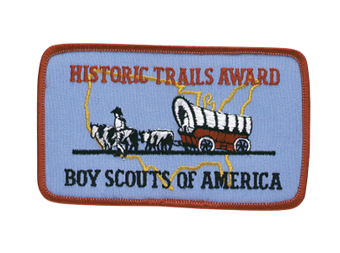

On certain special hiking routes across the country, Scouts can look back even as they move forward. That’s the promise of the BSA Historic Trails, designed to help young people connect with history in an immersive way.
You’ll find Historic Trails all over the United States — The Bradley Scout Reservation sits in close proximity to multiple trails from our historic past. (tap.scouting.org/bsa-historic-trails-index/)
Some of these trails follow the original journey or route taken by an important individual or expedition in history. Others connect several specific locations of particular historical significance.
“Experiencing the unique history of the areas we explore outside adds a deeper appreciation to adventures that Scouting provides and allows Scouts to learn the history that is right outside their doors,” says Andrea Watson, the BSA’s director of outdoor programs and properties. “We are so blessed to have so many well-preserved historic places to explore.”
Love of America and devotion to our country depend upon a thorough appreciation of the ideals, principles, and traditions that have made our country strong. Historic Trails Award requirements emphasize cooperation between historic societies and Cub Scout, Scouts BSA, Venturing, and Sea Scout units. Scouts should establish a close relationship with a local society as soon as possible when planning a historic activity—most communities have such societies.
Reports from many units indicate that these societies have been eager to offer their cooperation by:
• Suggesting trails or sites that are suitable for Scout historic activities and exploration
• Providing Scouts with historic information about the trails or sites
• Offering guidance to Scouts during restoration and marking projects
• Financing the cost of materials used by Scouts for restoration and marking projects
• Staging historic pageants and ceremonies with Scout participation
• Directing public attention to Scout historic activities through newspapers, television, and radio Visit the Guide to Safe Scouting for current youth protection policies
Award Requirements To earn the award, members of your unit must plan and participate in a historic activity. A unit historic activity requires members to
1. Locate a historic trail or site and study information relating to it. (The information may be obtained from an adult historic society, public library, or people living near the trail or site. You can find BSA Historic Trails here: https://tap.scouting.org/bsa-historic-trails-index/ .
2. Hike or camp two days and one night along the trail or in the vicinity of the site. Options include an area hotel or the home of other Scouts.
3. Cooperate with an adult group such as a historic society to restore and mark all or part of this trail or site. (This may be done during the hike or overnight camp.) Or cooperate with such a group to plan and stage a historic pageant, ceremony, or other public event related to this trail or site—such an event should be large enough to merit coverage by the local press. Your unit leader must then file the Historic Trails Award application with your local council service center

Camp Patch History 2021-2026
2026- Live the Big Adventure. The continued series of the camp patch this year embraces the history of the BSR. The stagecoach stop that once was the center of the town of Cape Horn, is now the Hotel at the Bradley Scout Reservation. The patch gives omage to this mass transport of its day.

2025- Live the big remodel. There was no camp held at BSR in 2025. The total remodel was the plan for the season. Enjoy our new home. The patch used for the final year of Morrison was Sasquatch giving us the thumbs up for a job well done.

2024- Live the Big Adventure. The continuing series of Camp Patch this year displays the Lumberjacks of the bygone era. The rough and hardy individuals were instrumental in opening the wilderness. This spartan lifestyle led to grate legends of strength and stamina and live on in our “Bull of the Wood” award. With the traditions of lumber still ringing from the surrounding mountains, we benefit from the legacy of proper resource management of our forests.

2023- Live the Big Adventure. In keeping with our on-going theme of Live the Big Adventure, we introduce the second patch in the 6-patch series. This patch displays the old prospector, “Sourdough Sam” and his trusty side kick mule “Forty Gears.” The prospectors opened a lot of our Council’s territory with their search for riches untold in the form of gold. Much gold was found and the riches of their legacy lives on.

2022 Live the Big Adventure. This year’s patch is again inclusive of the Council’s two camping locations. It contains the image of a classic mountain man. This iconic symbol reminds us of the rich heritage of outdoor skills and adventure that we have inherited. As he looks to the high-country tops, we can imagine that we travel with him on the biggest adventure of all.

2021 Journey Together. This patch again joined Camp Morrison and Bradley Scout Reservation together under one council. The patch featured Pete Weiser traveling across the high country in his trapper canoe. Pete came west with the Lewis and Clark Corps of Discovery and after bonding with the local nations, was tasked with running a “salt camp” near the town and river that bear his name. The history of his life is somewhat limited, but legend claims that he still roams these mountains as a protector of the land. The exciting thing about this patch is that it is a New Council Shoulder Patch (CSP) for the council!

Driving Directions to Bradley Scout Reservation
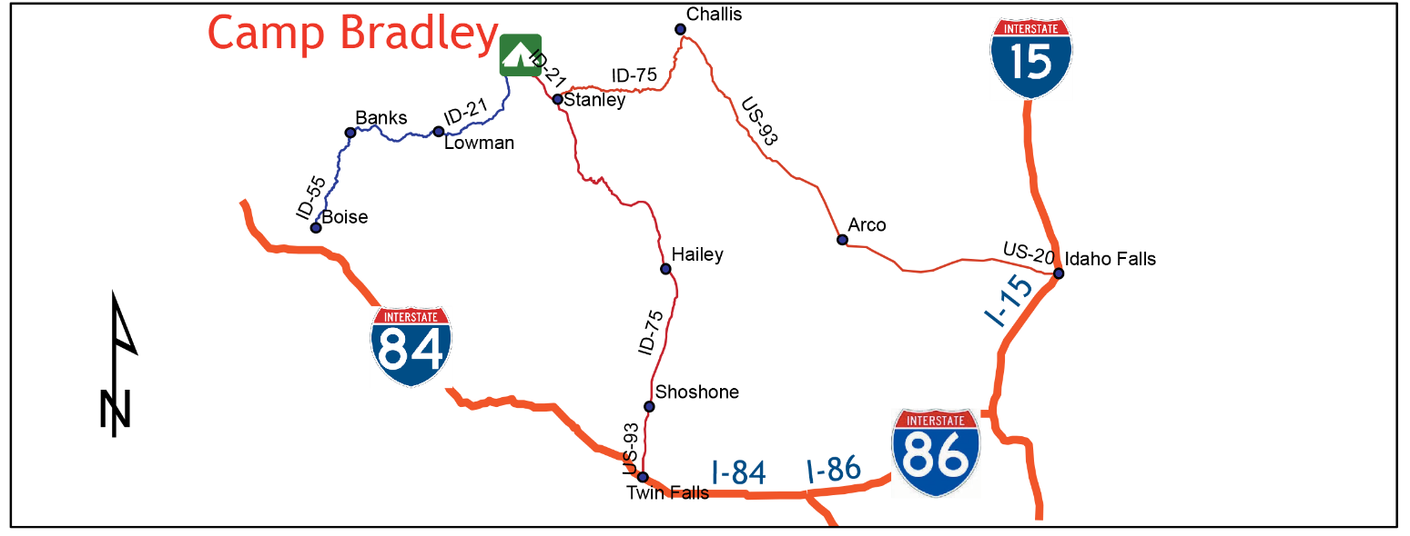

From Boise  (Beginning at the intersection of ID-44 W/W State St & ID-55 N). Turn right onto ID-55 N55 go 33.7 miles. Turn right onto County Hwy 17/ Banks Lowman Rd. Continue to follow County Hwy 17 for 33.3 miles. Turn left onto ID-21 N go 39.7 miles. Turn left onto Forest Rd 008 go 167 ft. Turn right onto Cape Horn Rd/NF-008/Seafoam Rd. Continue to follow Cape Horn Rd for 0.5 mile. Slight left onto Forest Rd 351, go 0.8 mile. Arrive at Bradley Scout Reservation. | From Idaho Falls  (Beginning at the intersection of I-15 & US-20 Continue onto US-20 W for 62.0 miles. Continue onto US-93 N/N Front St for77.6 miles. Turn left onto ID-75 S, go 54.8 miles. Turn right on ID-21 S/Eva Falls Ave go 18.3 miles. Turn right onto Forest Rd 008, go 167 ft. Turn right onto Cape Horn Rd/NF-008/Seafoam Rd. Continue to follow Cape Horn Rd for 0.5 mile. Slight left onto Forest Rd 351, go 0.8 mile. Arrive at Bradley Scout Reservation.

From Twin Falls
(Beginning at the intersection of I-84 & US-93 Follow US-93 to ID-75 for 24.7 miles. Continue straight onto ID-75 N, go 115.6 miles. Turn left onto ID-21 S/Eva Falls Ave, go 18.4 miles. Turn right onto Forest Rd 008, go 167 ft. Turn right onto Cape Horn Rd/NF-008/Seafoam Rd. Continue to follow Cape Horn Rd for 0.5 mile. Slight left onto Forest Rd 351, go 0.8 mile. Arrive at Bradley Scout Reservation .

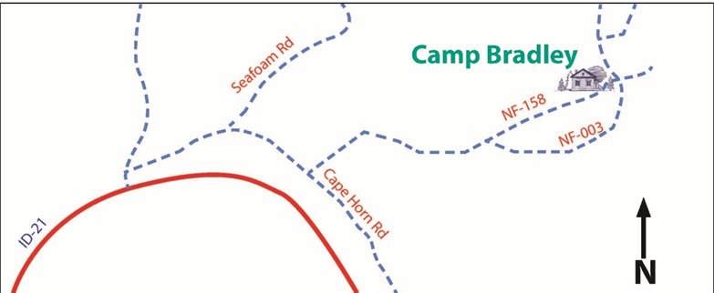

Vehicles in Camp, Vehicle Parking, and Your Info in the Vehicle

Please remain on established trails and roads. The vegetation at camp is very delicate and straying from established trails may cause damage that takes years to repair.
All vehicles must be parked in the parking lot and not in the campsites, unless approved by the Camp Commissioner. Please back vehicles into spaces and have your keys with you at all times in case of fire or other emergency evacuation orders. In an emergency, time is critical. Pulling out is 30% more efficient than backing out.
A vehicle identification form is located in the at the bottom of this page. It should be visible on the dashboard in the front windshield of all vehicles entering camp. Please fill it out using a “Sharpie” type marker.
Camp Commissioner will ensure that trailers and vehicles do not block trail access in any way to campsites, and are out of the way for camp vehicles to have unobstructed access for maintenance of camp facilities.
All roads have chains across them to block vehicles from Dinner on Monday to Lunch on Friday. These must be maintained up at all times and are only to be opened by authorized persons.

Please use fine tip marker while neatly printing the following information.

Place on dashboard on the driver’s side of the vehicle in plain sight.

-----------------------------------------------------------cut along this line----------------------------------------------------------

DRIVER VEHICLE ID

NAME _________________________________ TROOP ________________

CAMPSITE _______________________________________________________

CELL PHONE NUMBER ______________________________________________

Please back in vehicles and trailers

Map of Bradley Scout Reservation

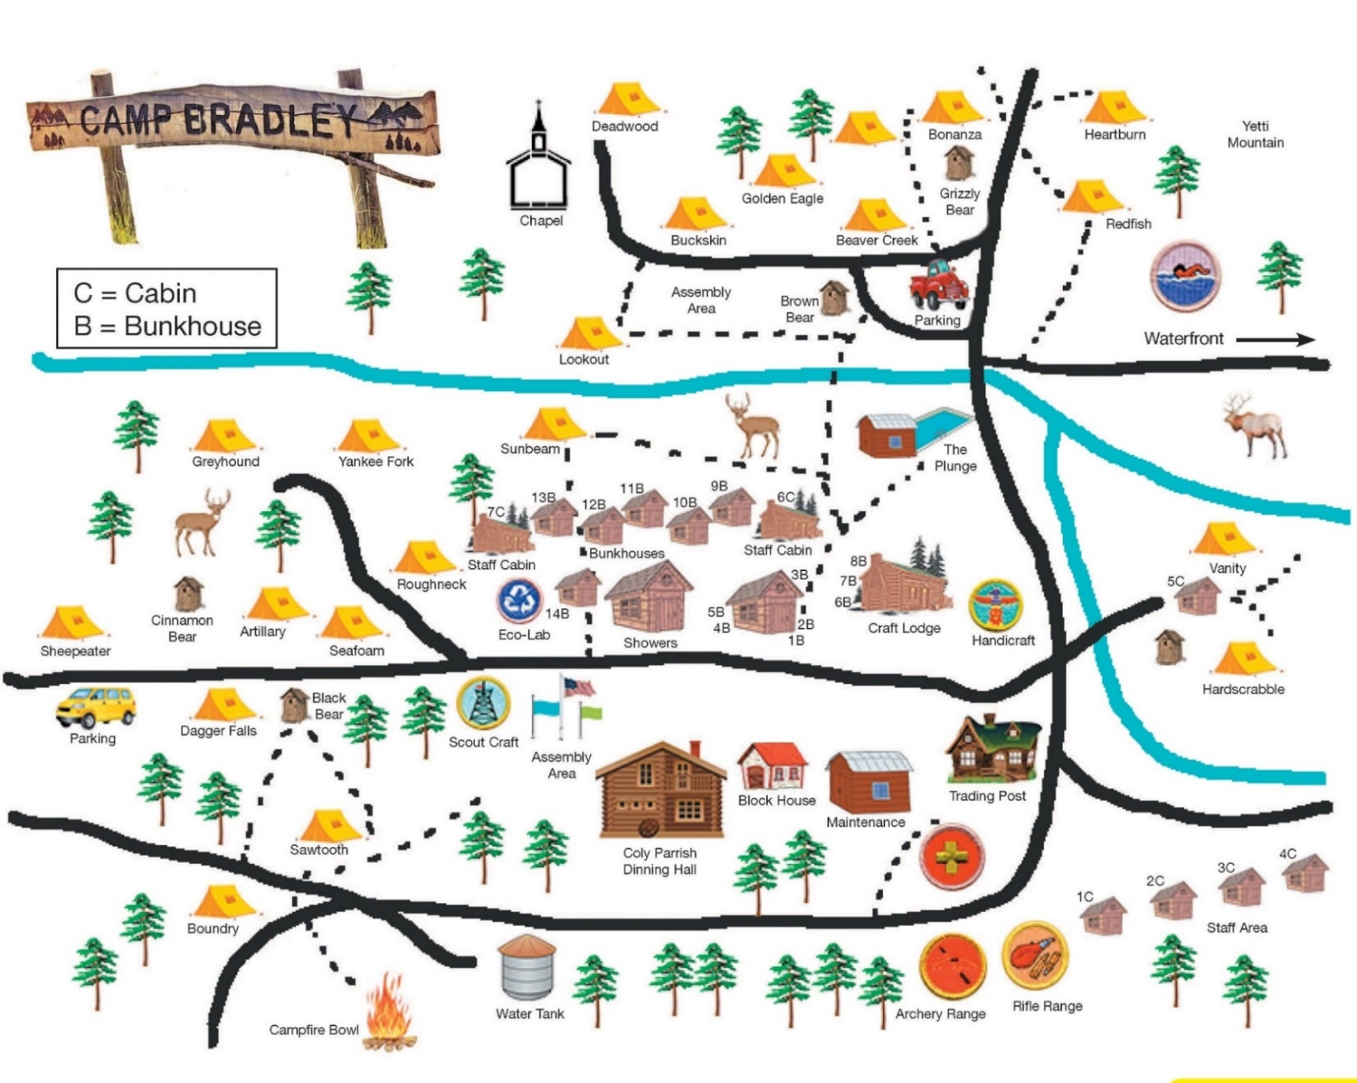

Get your camp on!!

