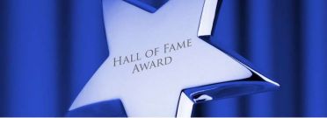
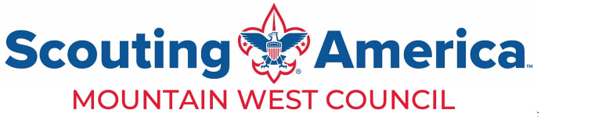

2026 nominations for the Mountain West Council Silver Beaver Hall of Fame Award are due no later than April 30, 2026. Late nominations will not be considered for this year.
The Silver Beaver Hall of Fame Award is to recognize Silver Beaver recipients who have continued their service to Scouting and youth in the Mountain West Council.
This nomination form must be sent to the local council office
To be eligible to be considered for the Hall of Fame Award a Scouter should:
1. Be currently registered and active in Scouting.
2. Have received the Silver Beaver Award in any Council 10 or more years ago. (2016 or earlier)
3. Must have continued to give active, noteworthy services to the Scouting programs and activities of the Mountain West Council or Scouting for a period of at least 10 years.
To prevent embarrassment, the candidate should not be notified of this nomination
Name__________________________________________
Spouse’s Name__________________________________
Home Address____________________________________________________________________________ City______________________________________________State_______________Zip code_____________ Phone______________________________________Email_______________________________________
Unit Type/Number or place of current registration_________________________________________________
District Name_________________________________________________________________________ Current Scouting position(s)__________________________________________________________________
Year the nominee received their Silver Beaver Award______________________________________________
How many years has this nominee been involved in scouting? ________________

Service (positions held) in Scouting since receiving the Silver Beaver Award (Please include dates) ________________________________________________________________________________________ ________________________________________________________________________________________Adult Scouting recognition and honors received since receiving Silver Beaver Award (Please include dates)
________________________________________________________________________________________________________________________________________________________________________________
Recognition/honor___________________________________________Date__________________________Recognition/honor___________________________________________Date__________________________Recognition/honor___________________________________________Date__________________________
Describe the noteworthy service to the Mountain West Council or to Scouting that prompts this nomination since the nominee has received the Silver Beaver Award (Please use additional sheets if necessary)
________________________________________________________________________________________
________________________________________________________________________________________________________________________________________________________________________________________________________________________________________________________________________________________________________________________________________________________________________________________________________________________________________________________________________________________________________________________________________________________________________________________________________________________________________________________________________________________________________________________________ ________________________________________________________________________________________________________________________________________________________________________________

Submitted by:
Name_______________________________________Email________________________________________ Address________________________________________________________________________________ City_____________________________________State_____Zip_______________Phone_______________
Date Submitted: __________________________ Date Received by the Office: _______________

