Join Us!
American Chestnut Seedling Planting
Idaho State Veterans Cemetery
Saturday 10 AM, April 25, 2026 (One Day after Arbor Day)
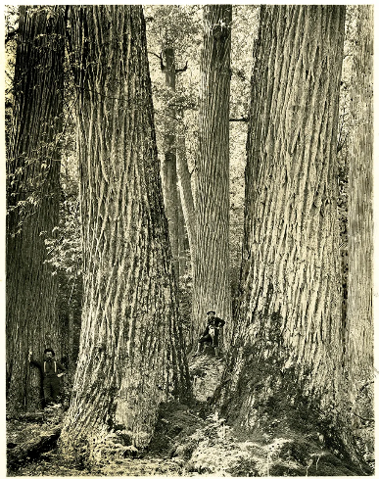
American Chestnuts were the premier forest tree in the Eastern United States until an introduced fungus wiped out the trees from their natural range between 1903 & 1940. This was one of the greatest biological disasters to engulf the United States. The American Chestnut Foundation (TACF) is diligently working to bring back a viable, blight resistant American Chestnut.
To assist them in this effort, we will be planting these seedlings on the berm near the edge of the cemetery, providing living sentinels between the adjoining neighborhood and our hallowed ground that serves as the resting place for our honored Idaho veterans.
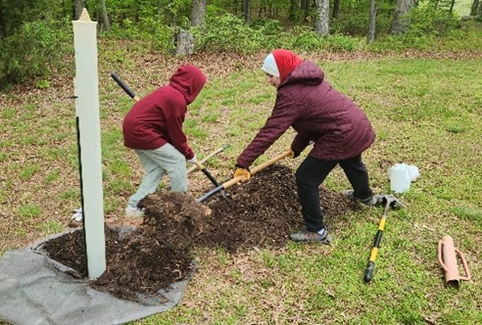
We are looking for Scouts to help us plant these seedlings, install protective shelters, water, and apply weed block to give these trees a good start. Tools and gloves will be provided on site. A member of the TACF will be there to instruct the scouts.

