

Mountain West Council
Commissioner Conclave March 21, 2026
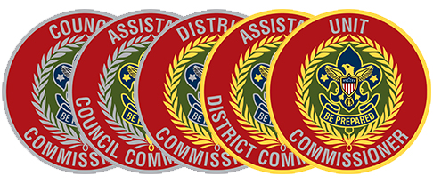

Mountain West Council Scout Service Center
9 am to 4 pm

March 21,2026

