
At the request of Scouting America’s National Council, the Mountain West Council determined the following policy for Cub Scout and Arrow of Light for winter camping:
Cub Scouts, including Arrow of Light Scouts, may not tent camp from November 1st through March 1st (daylight savings) of any calendar year. Furthermore, they may not tent camp outside of these dates when the ambient outside air temperature or wind-chill is forecast to be 32 degrees Fahrenheit or less.
Cub Scout/Arrow of Light winter camping in indoor facilities is authorized if Guide to Safe Scouting leadership requirements are met.

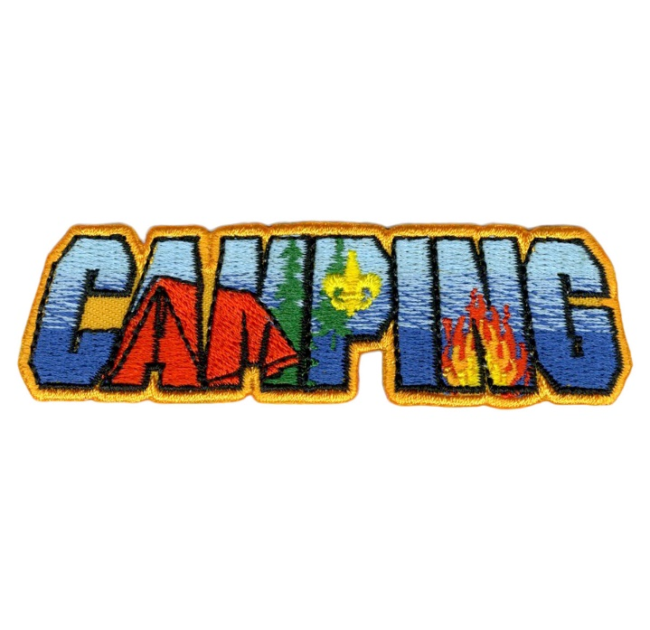
Please keep in mind at least one registered adult who oversees the planning and is in attendance for the campout must be trained in Basic Adult Leader Outdoor Orientation (BALOO).
Hazardous Weather Training also requires training for adult leaders and is recommended for all adults.

Below is the 2024 Scouting America policy on CS camping for reference.
Scouting America has established the following guidelines for a safe and quality camping experience. Fundamental guiding principles for camping:
- Supervision of camping activities must include qualified, registered, adult leadership.
- At a minimum, one leader present is currently in Hazardous Weather Training for all unit types. It is recommended that all leaders complete this training every two years.
- At a minimum, Cub Scout Packs, Webelos dens and Arrow of Light dens / patrols who camp overnight must have a BALOO trained leader present. BALOO is recommended for all Cub Scout leaders who go camping with Cub Scouts.
- Local council approval is needed for unit-coordinated overnight camping activities involving other units not chartered by the same organization. Units that wish to host events involving other units that do not share the same charter partner must have approval from their council. This includes events for packs, troops, crews, and ships from the same council; neighboring councils; the same territory; or other territory.
- Activities must be age- and skill-appropriate for all participants.
- Youth who are not registered in the unit may not accompany parents or siblings in camping programs of Scouts BSA*, Venturing, and Sea Scouting.
- For example, siblings who are not registered in the specific troop may not attend Scouts BSA troop campouts as part of a “family camp”. Youth who are not registered in the unit may not accompany parents or siblings in camping programs of Scouts BSA*, Venturing, and Sea Scouting.
- For council coordinated overnight camping, NCAP standards for short- or long-term camps must be met as minimum safety and quality standards.
Additional program-centric requirements and limitations to camping may also exist. These are introduced in training modules required of unit leaders and specified in other sections of the Guide to Safe Scouting.
*See Guidelines for Arrow of Light Scouts Camping Overnight with Scouts BSA below.
Additional Guidelines Specifically for Cub Scout Unit-Coordinated Camping
- Cub Scout camping is a family-centric program.
- Cub Scout camping is limited to their council’s designated locations with appropriate facilities.
- Councils use Pack Overnight Campout Site Appraisal Form (www.scouting.org/wp-content/uploads/2018/07/430-90218-PackOvernightForm_Fillable.pdf) to review and designate locations.
- Units can request from their council a site appraisal but cannot do their own appraisal.
- Cub Scout pack unit coordinated camping is limited to no more than two consecutive nights.
- Cub Scout youth may tent with a parent or guardian and siblings as outlined in Scouting’s Barriers to Abuse.
- As with all Scouting activities, Lion Cub Scouts and Tiger Cub Scouts must have their adult partner present to take part in overnight camping.
- For all other ranks: only in exceptional circumstances, a Cub Scout whose parent or legal guardian cannot attend a unit overnight camping trip may participate under the supervision of another registered adult member in Scouting who is a parent of a Cub Scout who is also attending. The unit leader and a parent or legal guardian must agree to the arrangement, and all Youth Protection policies apply. At no time may another adult accept responsibility for more than one additional “nonfamily member” youth.
Webelos and Arrow of Light Camping Additional Guidelines
Effective June 1, 2024, Webelos is the designated program for 4th graders and Arrow of Light is the designated program for 5th graders. As such, the Arrow of Light program is no longer combined with the Webelos program and the purpose of Webelos (4th grade) is no longer to prepare Cub Scouts to join Scouts BSA. The purpose of the Arrow of Light program is to prepare for Arrow of Light Scouts to join a Scouts BSA troop.
- Only Webelos Scout dens and Arrow of Light dens/patrols may conduct den coordinated overnight campouts. Webelos Scout dens and Arrow of Light dens/ patrols coordinated overnight campouts are restricted to no more than two consecutive nights.
- Webelos den or Arrow of Light den/patrol coordinated camping is only for the youth members of those dens/patrols, their parents, and their registered adult leadership.
- Webelos den and Arrow of Light den/ patrol coordinated campout must have a BALOO trained adult leader in attendance and all of Scouting’s Youth Protection policies apply. Reminder – Cub Scout overnight camping is limited to their council’s designated locations with appropriate facilities.
- During Webelos Scout dens and Arrow of Light den/patrol camping, each Scout should attend with their parent(s) or legal guardian(s). A Webelos Scout or Arrow of Light Scout whose parent or legal guardian cannot attend a Webelos den or Arrow of Light patrol overnight camping trip may participate under the supervision of at least two registered leaders. The leaders and a parent or legal guardian must agree to the arrangement, and all Youth Protection policies apply.
- Webelos Scouts and Webelos Scout dens may not participate at a Scouts BSA troop unit campout or at a Scouts BSA “camporee” or other events designed for Scouts BSA during the day and/or overnight, even as visitors.
* Guidelines for Arrow of Light Scouts Camping Overnight with Scouts BSA
- Arrow of Light Scouts can participate and camp at a unit coordinated campout with a Scouts BSA troop they are eligible to join. They must attend as an Arrow of Light den/patrol under the supervision of two deep leadership from their Arrow of Light den/patrol or pack. All Cub Scout camping requirements still apply, including the Arrow of Light den/patrol must have a BALOO trained adult leader in attendance and all of Scouting’s Youth Protection policies apply.
- Arrow of Light Scouts may participate at a Scouts BSA “camporee” (council coordinated, short-term camp, see NCAP SA-001) during the day and/or overnight in one of two ways:
- With their Arrow of Light Den/Patrol. Arrow of Light Scouts can attend as an Arrow of Light den/patrol under the supervision of two deep leadership from their Arrow of Light den/patrol or pack. The Arrow of Light Scout’s parent or legal guardian(s) may attend with the Arrow of Light den/patrol and their child, either alongside the two-deep leadership or as part of it if they are registered with the pack. Or
- As an Individual Scout. Arrow of Light Scouts can attend with their parent(s) or legal guardian(s) if the local council coordinates two deep leadership per NCAP Standard HS-502.

