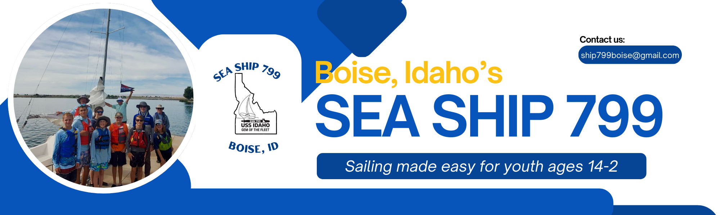

Overview
Launched in July 2024, the Sea Ship program aims to teach young people how to sail, engage in water activities, and maintain equipment, all while planning these activities with adult supervision. Sea Scouts welcomes both boys and girls seeking more adventure on the lakes and rivers of southwest Idaho.
Youth aged 14 to 20 are invited to join.

Relevant Resources
Seascout.org
Sea Ship 799, Boise, ID / Facebook
Sea Ship 799 Coming Soon on You Tube

Did you know:
In 2024, as the USS Idaho prepared for its christening as the latest Virginia-class nuclear fast attack submarine to join the U.S. Navy fleet, we began forming the Boise Sea Ship.
To honor the USS Idaho SSN 799, the Boise Sea Ship, with the endorsement of the USS Idaho Commissioning Committee, has selected 799 as our ship's identification number.

Welcome to Sea Ship 799, Boise
Meeting Dates | Second and Fourth Thursday of the month at our “clubhouse” in Meridian  near Lewis & Clark Middle School  Time: 6:45-8:00 PM
Activities | Summer months, sailing as much as possible when the winds are between 5-10 knots / over 12 knots will be to the adult discretion  One overnight per month is the goal - determined by the sea ship members.  A week-long cruise annual to be determined by members and parents.  Fall, Winter, Spring activities will be determined by the members  Examples: service projects, boat repairs, engine service, fundraisers to support the budget, day at Bogus, learn to snorkel/scuba dive, etc.
Fees | Scouting America youth or adult application / if already registered, the application for joining would be a multiple application at no charge  - $85 + $2 for accident insurance  - $30 Annual dues towards vessel repair and licensing  - $20 average monthly overnight activities  Ship Venmo: Sea-Ship@799
Leadership and Advancement  2025 Sea Scout Manual:  seascout.org/manual-resource-center/ | Youth members run the ship and elect their leaders twice a year in October and March. The Boatswain’s Mate will advance into the Boatswain position after the 6 month term. Calendar planning will occur in September and February. The Sea Ship offers a Small Boat Sailing merit badge clinic for others scouts annually in August.  Boatswain - President  Boatswain’s Mate for program  Boatswain’s Mate for Administration  Yeoman - Secretary  Purser - Treasurer  Storekeeper - Equipment manager  Advancement - scouts in a troop can continue to earn service hours, mb while in the ship, as long as the Scoutmaster and Skipper are aware of the scout’s intentions. Most of the adults are ready to assist with any scout’s advancement. A member does not have to advancement but learn the basic skills to operate the sailboats and other equipment properly and safely.  Four ranks in Sea Scouts, equal to the Scouting troop level  1. Apprentice  2. Ordinary  3. Able  4. Quartermaster - highest rank in sea scouts, on the same level as Eagle Scout
Joining and beyond | Joining the ship begins with:  1. Application and fee if new to scouting  2. Scouting America health forms part A & B provided to Skipper  3. Sea Scout uniforms / Navy Blue Shirt and pants by “Dickies” usually available in Walmart. Hat and shirt emblems available at the scout store. Activity shirts can be purchased through the ship or wear a scouting shirt  4. Refillable water bottle  5. Sailing gear (hat, sunglasses that reflect the glare, water shoes, swim trunks)  Beyond  Bring your ideas of a new adventure, this group is here to try new activities while learning to be proficient.

Adult Committee
This is the current adult committee, adults who are registered with Scouting America and trained. Parents are welcome to take the online Safeguarding Youth Training to attend day activities or register w/ Scouting America to attend overnights.
Charter Partner: Mountain West Council
Executive Officer: Geoffrey Wardle
Charter Org Rep: Mark Westcott
Committee Chair: Donna Kemper
Skipper: Wayne Welter
Skipper’s Mates: Jonathan Van der Veen and Michael Edwards
Treasurer: Angie Anderson
Adult members: Dotty Jones, Bobby Huffman, Peter & Laura Barton

